Town of Lisbon
Mark Stevens
Lisbon Parks & Recreation Director
18 School Street
Lisbon Falls, ME 04250
(207) 353-2289
mstevens@lisbonme.org

TO: Glenn Michalowski; Town Manager
SUBJECT: May 2023 Report
DATE: June 13, 2023

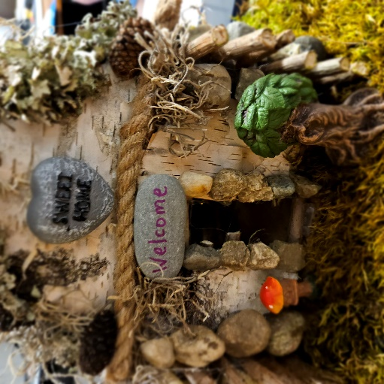
May is a beautiful month and we are always invigorated by enhancing that beauty through our parks, gardens, and trails. Our wonderful staff gained two new parks crew members: Carter Roy transitioned from seasonal to full-time employment, and Hank Arsenault was hired as a part-time gatekeeper/groundskeeper for the summer at Beaver Park. Additionally we warmly welcomed back Jeffrey Arsenault to full-time seasonal for the third year in a row.

One of our favorite beautification projects for this spring was the institution of a Fairy Trail at Beaver Park. With the help of many local talented home crafters and artists, we have a dozen little fairy homes established along their own trail at the Park. We hope to add many more to encourage the creativity and imagination of old and young alike.

We continue to clean up winter damage, most especially the May Day storm that overflowed the walking path and washed a substantial amount of garbage downriver from Lewiston. We continue to establish beds and grounds for planting. The wheel garden, Oak Street Park, MTM, Beaver Park, Route 9 median, all entrance signs, and more have received their spring flower plantings.

The senior program is at capacity for trips and meals the minute they open; but the Sunshine Hill group took a moment out of their busy schedules to join our Department in nominating John Curtis for the Spirit of America service award this month for our town, which he was awarded, even against many other nominees. From his nomination letter:

We are writing to nominate John Curtis of Lisbon, Maine for the Spirit of America Volunteerism award.
If you have been to the MTM Community Center at any point in the last decade, you have likely seen John Curtis. Maybe his signature printed knee socks and straw hat caught your eye. Maybe it was his even more signature smile.
When you saw him, there is no doubt that he was working. He might have been washing dishes, flipping bacon, baking, serving, packing, setting up tables, or mixing punch for the Sunshine Hill Seniors meals. Or perhaps you saw him around a corner with his toolbox, glazing a window, building a helpful shelf, or leveling an unlevel-able floor.
He is the first one to arrive and last one to leave to prep, cook, serve, and clean for weekly meals. On day trips he is there to pack, warm up and troubleshoot any issues on the bus, keep an eye on folks’ needs, and be the first out of the car to place the step stool for an easier exit for the person behind him. He makes coffee when small groups gather and serves it on a tray, returning later to make sure their dishes have been done.
The MTM is as patchworked as one of the quilted blankets made by the senior ladies, and there is always something needing mended. John has a quiet radar of such things, making little notes in his head, returning the next day with a bit of putty or a bolt or a screwdriver to bring another corner of the building back into service again. He is our own personal MacGuyver. It is a rare day that something breaks and John isn’t right there behind it, saying “I can fix that.”
When John began volunteering with Aline in 2015, he was looking for a bit of a social outlet and an opportunity for his endlessly creative and generous hands to offer service. As the years have grown, the amount of time he has given is staggering – roughly twenty hours a week for almost nine years.
John is always watching, looking for ways to make life better for others. At one point during the anxious years of Covid regulations, he saw the children getting off the After School bus, and reflecting on what a difficult time it was in their young lives, made a plan to bring them a little joy. He brought in his hand-crank ice cream maker and spent an entire afternoon churning home-made ice cream for sixty five children. He simply said, if he didn’t do it, some of them might never get a chance to try it.
His quiet kindness, gentle humor, and heart of gold have touched all aspects of the Senior Program, and anyone who encounters him just passing through. He has a magnetism that he doesn’t seem to realize. If Aline plans a meeting or a place to travel, she is often told, “Make sure you bring John.” He is the program’s biggest supporter and her right-hand-man in making sure everything gets accomplished, which at the MTM often means feeding twice as many on half as much. Aline says she may be the Senior Coordinator, but John is the “presence” and the heart of the program.
Aside from his countless hours for this program, John is a regular volunteer at the Parks & Recreation Annual Winterfest and the Pejepscot Sno-Chief’s World’s Greatest Sleigh ride for decades. One of his most generous gifts is the pleasure he takes in serving. He makes you want to be there and give of yourself as well. In spite of this, or maybe because of it, he never wants recognition and sweeps his hand away at praise or thanks. Instead, he turns to find the next thing that needs to be done.
A few paragraphs will never do justice to this great man, who, in his eighties, outpaces everyone else in his kindness, work ethic, humor, and patience. We are the lucky ones who get to work beside him every day.

On the other side of the MTM community center, summer planning has been non-stop, with interviews every day to hire summer staff. Notably, we hired our After School Coordinator, Anna Willey, to take on the position of Summer Day Camps Coordinator. We know she will excel at this position and bring her joy and wisdom to our hundreds of campers!
The MTM building itself was the subject of much discussion this month, and we thank Chief Ryan McGee and Lieutenant Jeff Picard for their lengthy walk through and discussion with us regarding the building current security and future plans to enhance safety measures.

The Recreation committee met this month and discussed increasing scholarship funding to needy families, as well as began the process of awarding current funds to those who applied. The office staff additionally received training on three Clover registers in preparation for the Moxie festival and other usages from this department and beyond.

