PLANNING BOARD MINUTES

march 14, 2024
Shaun Carr, Chair– Regular 2024
Nicholas Craig, Vice Chair– Regular 2026
Dan Leeman- Regular 2025
Christopher Huston– Regular 2025
Patrick Maloy– Regular 2024
William Kuhl- Associate 2024
Natalie Thomsen – Associate 2025

- CALL TO ORDER: The Chairman, Mr. Carr called the meeting to order at 7:10 PM.
- ROLL CALL: Regular members present were Shaun Carr, Chris Huston, Nicholas Craig and Dan Leeman. Associate Members William Kuhl and Natalie Thomsen were present as well. Mr. Maloy was excused. Also present was Mark Stambach, Code Enforcement Officer; Kate Burch, Town Planner; Sarah Bennett, Assistant Town Manager; Kristin Collins, Town Attorney; Councilor Larochelle, Town Council Liaison; and 4 audience members. The Chairman extended voting privileges to Ms. Thomsen.
- REVIEW OF MEETING RULES:
The Chairman explained the meeting rules are located in the folder on the wall.
- WRITTEN COMMUNICATIONS: Minutes of February 22, 2024
The meeting minutes were distributed to all the members. The Chairman asked if there were corrections or additions.

VOTE: (2024-23) Mr. Craig, seconded by Mr. Leeman moved to approve the Minutes of February 22, 2024.
Vote: 5-0 Carried.
- PUBLIC HEARINGS – Case #24-03- Conditional Use Application- Haven, LLC

The Chairman opened and closed the Public Hearing with no public comments.

6. UNFINISHED BUSINESS - Case #24-03- Conditional Use Application - Haven, LLC
Amanda Boucher
143 Lisbon Street
Lisbon, ME 04250
Map U22, Lot 003

Mr. Stambach said this application was submitted to bring the property into compliance. There was a certificate of occupancy issued by the previous code enforcement officer without any Planning Board review or approval. Mr. Stambach stated a portion of this property is in the Aquifer Zone 1, which would not allow for a Hair Salon, however the entire building is located in Aquifer Zone 2, which allows for a Hair Salon with a conditional use application submitted and approved by the Planning Board.

Ms. Burch went through the required Checklists.

VOTE: (2024-24) Mr. Leeman, seconded by Mr. Craig moved to approve the application for Case #24-03-Conditional Use Application for Haven, LLC.
Vote: 5-0 Carried.

- NEW BUSINESS – Extension Request for Lisbon CSG, LLC Solar Project

Chris Byers, representing CSG, LLC Solar project on Upland Road stated they are requesting another extension. He said they are currently working with CMP to potentially adjust the size of the project to downsize it. He said the footprint of the project will be the same.

Mr. Huston asked if there could be a landscaping plan done to hide the view from the two new houses that were built since the project started. Mr. Byers said they would show that on the re-design that will be submitted it to the Code Enforcement Officer, specifically near the Pelletier property.

VOTE: (2024-25) Mr. Leeman, seconded by Mr. Kuhl moved to extend the CSG, LLC Solar Project for 1 year with conditions that the plan reflect the landscape blocking of the walking trail and abutters.
Vote: 5-0 Carried. (Mr. Craig, an abutter to the project, abstained) The Chairman extended voting privileges to Mr. Kuhl.

- OTHER BUSINESS – Case #21-15- Subdivision Review reconsideration – Ralph Sawyer
Mr. Stambach said the applicant came in to the town office to submit the final plan for Planning Board signatures and noticed the conditions were not the same as what the Planning Board had put on it for final approval. After speaking with the Town’s legal department, it was said that it could be brought back to the Planning Board for reconsideration.
The applicant requested it be brought back to the Planning Board for reconsideration.
Mr. Stambach stated he spoke with the Town Attorney for guidance on the suitable language for the requirement of the conditions. The wording the Attorney came up with was “Sawyer Landing Road is a private road and is to be built to the Town of Lisbon’s Road Standards. No building permits shall be issued until the private road has been developed to the Town of Lisbon road standards as confirmed by the Code Enforcement Officer and the Public Work’s Director.”
Kristin Collins, Town of Lisbon Attorney said she wasn’t sure if there is something in the Ordinance that states who has the specific authority to determine compliance so she thought it would be helpful to add some clarity to the condition. She said adding the Public Work’s Director’s authority would be helpful since this issue deals with road construction. Ms. Collins prefers the onus be on the developer rather than the first building permit. She said this puts the onus on the developer before they’re actually going to sell the lots.
Mr. Stambach said the Town Attorney has concerns about the Waiver on the turnaround requirement that had been discussed at the last meeting. She wants to make sure that the Findings of Facts meet the standards for the subdivision.
Ms. Burch recommended that the Board make a finding that the turnaround is not necessary in the interest of public health and safety because the plan shows adequate space for an emergency vehicle to turnaround.

Ms. Burch clarified the changes being done tonight are as follows:

- Planning Board amended the Condition of Approval to read “Sawyer Landing Road is a private road and is to be built to the Town of Lisbon’s road standards. No building permit shall be issued until the private road section has been developed to the Town of Lisbon’s road standards as approved by the Code Enforcement Officer and Public Work’s Director.”
- Adding a Finding of Fact that a turnaround is not necessary in the interest of public health and safety because the plan shows adequate space for an emergency vehicle to turnaround.

VOTE: (2024-26) Mr. Craig, seconded by Mr. Leeman moved to revise the condition to match the language that’s been recommended as follows: “Sawyer Landing Road is a private road and is to be built to the Town of Lisbon’s road standards. No building permit shall be issued until the private road section has been developed to the Town of Lisbon’s road standards as approved by the Code Enforcement Officer and Public Work’s Director.”
Vote: 5-0 Carried.

VOTE: (2024-27) Mr. Craig, seconded by Mr. Leeman moved to enter a new Finding of Fact to support the waiver already granted with the language specified by the Town Planner that the turnaround is not necessary in the interest of public health and safety because the plan shows adequate space for an emergency vehicle to turnaround.
Vote: 5-0 Carried.

Ronald Bonsaint, Lisbon resident, stated he has two parcels on Bowdoinham Road that abut each other. He said one parcel is approximately 10 acres and two other parcels that have about 18 acres which are already approved for two rear lots. Mr. Bonsaint said the other three lots are in limbo. He said they have a 50 foot easement going through the property now and finds it would be expensive to have to tar the road. He is asked how the process of making this easier is going.

Ms. Burch stated that this process is a long one and the Planning Board has been and is working on this issue. They will have a Workshop tonight for further discussion and will be sending out information on the updates.

CODE ENFORCEMENT OFFICER – NONE
- ADJOURNMENT
VOTE: (2024-28) Mr. Leeman, seconded by Mr. Craig moved to adjourn to Workshop at 7:55 pm.
Vote: 5-0 Carried.
- WORKSHOP – A. ROS Ordinance Updates & Contract Zonings
Ms. Burch presented the Board with the Draft updates to the Open Space Subdivision Ordinance listed after the following comments.
Ms. Burch stated they have proposed a couple of targeted zoning changes. The first one is to Amend Section 70-362 to allow residential subdivisions in ROSII. She said as a result of that, there is an existing Ordinance that all subdivisions on land over 10 acres in ROSII have to be open space subdivisions.
Ms. Burch said the only policy changes that are proposed are to add Road and Driveway Standards.
Mr. Craig wanted clarification on the requirements for a paved driveway. He said as he understood it, land over 10 acres has to be an open space subdivision with no requirement for paving the road, but land under 10 acres and the road serves two or more lots, than it does have to meet road standards.
Ms. Burch recommended the Town work on a specific Road Standards Section with table to add to the Ordinance with a waiver procedure that says the Planning Board can use its discretion to make the context appropriate.
Ms. Thomsen stated that some Towns adopt an Ordinance that states they will only allow so many houses on a road that is a dead end or isn’t up to Town standards or Private Road standards.
Mr. Stambach reminded the Board to keep in mind the new State Statute for Accessory Dwelling Units, every single lot that’s created now can have two dwelling units at a minimum.

- Draft Update:
Sec. 66-155. - Open space subdivisions.
- Purpose. It is the policy of the Town of Lisbon to encourage the use of open space subdivisions in order to preserve open space, provide for agriculture and forestry as well as recreational land, preserve other resources identified in the Town of Lisbon comprehensive plan, and harmonize new development with the traditional open, wooded, agricultural and village landscapes.
An open space subdivision achieves the purposes of this performance standard by reducing the lot size, frontage and setback requirements as contained in Chapter 70, modifying the road design standards and clustering housing and uses in those areas where they have the least impact on identified environmental, agricultural and other open space resources. These resources are then permanently preserved by the use of covenants and restrictions or conservation easements that run with the land. The open space principle can be applied to subdivisions of any size. It shall not be construed as granting variances from dimensional standards when the planning board grants waivers provided for in this section as allowed for in 30-A M.R.S.A. § 4353.4-C.
(b) Applicability. The provisions of this ordinance shall be mandatory for all subdivisions of 10 acres or greater in the ROS-I and ROS-II zones, and optional for all subdivisions in any other zone.
(c) Planning board review.
(1) The planning board shall review the application in accordance with 30-A M.R.S.A. § 4404 and the chapter as modified by the provisions of this section.
(2) The submissions for an open space subdivision shall include all plans and materials required for a conventional subdivision under this chapter.
(3) Lots and Dwelling Units. In planning board review and approval of an open space subdivision, the following requirements shall apply and shall supersede any inconsistent or more restrictive provisions of this chapter or Chapter 70, Zoning.
a. All open space subdivisions shall meet the use standards of the zoning district in which they are located.
b. The overall density of the subdivision shall not exceed the density requirements of the zoning district in which it is located. In calculating overall density, the land area contained in road rights-of-way shall be deducted prior to determining density.
c. A lot for a dwelling unit created as part of an open space subdivision shall not be further divided.
d. Density bonus. The planning board may grant a density bonus of one lot or dwelling unit for each ten lots or dwelling units when it makes a written finding that the open space subdivision design provides public access to open space or pedestrian friendly layouts through the use of sidewalks, wider paved roads or trail systems.
e. Low Impact Development (LID) Bonus. A 10% increase in the number of dwelling units allowed may be granted by the Planning Board if LID practices according to Maine State Planning Office’s “LID Guidance Manual for Maine Communities” are incorporated into the subdivision.
(e) Layout and siting standards. In planning the location and siting of residential structures in an open space subdivision, priority should be given to the preservation of the open space for its agriculture or natural resource value with residential structures located and sited on the lower valued natural resource portion of a parcel.
The building lots and designated open space shall be laid out and be sited according to the following principles to the greatest extent feasible. The planning board in its discretion shall resolve conflicts between these principles as applied to a particular site.
(1) Maximize contiguous usable area for agriculture, forestry, conservation areas, or open space for recreation;
(2)Preserve essential habitats of rare, threatened or endangered wildlife, rare or exemplary plants and natural communities, and high value plant and animal habitat areas identified on State Beginning with Habitat maps in protected open space;
(3) Preserve rural landscape features, including significant trees, tree lines, stone walls, and other natural features; (4) Create linkages to existing open space, trails, natural areas, and habitat corridors where possible;
(5) Lots within woodlands or along the far edges of open fields to allow new residential structures to be visually absorbed by natural landscape features;
(6) Lots where scenic views from public roadways are least likely to be blocked or interrupted;
(7) Architectural compatibility of new construction with existing buildings in the community.
(e) Space standards.
(1) Shore frontage, shore setback and shoreland density requirements shall not be reduced below the minimum required in the zoning district.
(2) Distances between residential structures shall be a minimum of the height of the tallest adjacent structure.
(3) When individual lots will be laid out, the required minimum lot size or minimum land area per dwelling unit for the building envelope may be reduced. Unless public sewage collection and treatment is provided, no lot shall be less than 20,000 square feet.
(4) Minimum road frontage requirements may be waived or modified by the planning board provided that:
a. Any applicable provisions regarding roads in subsection (g) of this section are satisfied; and
b. Adequate access and turnaround to and from all parcels and/or structures by fire trucks, ambulances, police cars and other emergency vehicles can be ensured by private roads and/or common driveways.
(5) A reduction of required setback distances may be allowed at the discretion of the planning board, based upon the public benefits to be achieved from the design.
(6) No individual lot or dwelling unit shall have direct vehicular access onto a public road existing at the time of development.
(f) Utilities.
(1) All utilities shall be installed underground unless specifically waived by the Planning Board. Transformer boxes, pumping stations and meters shall be located so as not to be unsightly or hazardous to the public.
(2) All structures requiring plumbing in the development shall be connected to the public sewer system, individual septic systems, or a shared subsurface disposal system in accordance with the minimum standards set forth in the State of Maine Subsurface Wastewater Disposal Rules. Proposed systems shall in no way endanger groundwater supplies which are currently being utilized as a water source for any existing development or which are to be utilized as a common or individual water supply for the proposed development.
(3) Shared subsurface disposal systems may be permitted in designated open space provided that requirements of the Maine State Plumbing Code are met, including appropriate provisions for legal obligations related to maintenance and replacement.
(g) Roads and common driveways. The planning board shall require private roads and common driveways to comply with the design standards set forth in this chapter except as provided in subsection (g)(4) of this section.
(1) Common driveways are allowed and encouraged where appropriate to access individual lots. The following design and construction standards shall apply:
(a) The maximum length shall not exceed 1000 feet.
(b) All common driveways in excess of 500 feet shall contain at least one 10 foot by 30 foot turnout. The exact location shall be determined by the Planning Board with the review of the Fire Department.
(c) The common driveway shall have a minimum 25 foot right of way (ROW) for up to 2 lots or dwelling units, and a minimum 50 foot ROW for over 2 lots or dwelling units.
(d) The travel way shall be 12 feet wide with 2 foot graded and grassed shoulders, and shall be located as close as possible to the ROW centerline.
(e) The travel way shall be constructed of a minimum of 12 inches of gravel.
(f) Drainage ditches and culverts shall be provided as necessary.
(2) Roads serving open space subdivisions shall meet the following standards:
(a) Roads serving open space subdivisions shall have a minimum 18-foot travel way with a minimum shoulder width of 3 feet, and a maximum pavement width of 20 feet. All roads shall have a minimum 50 foot ROW.
(b) Where feasible, horizontal road alignments shall work with the topography and existing site conditions to follow the natural contours and avoid physical features that give the land its character.
(c) Open fields, agricultural lands and sensitive habitats should be crossed at the edges, preferably along hedgerows and tree lines when possible. Roadways shall avoid bisecting fields.
(d) Where feasible, proposed roads should follow any existing gravel/dirt road that has value as a local historic resource.
(e) When roads cross significant viewsheds in open fields, consideration shall be given to design approaches that will minimize their visual impact.
(f) Where existing roads must be widened to accommodate increased traffic volumes, care shall be taken to preserve mature roadside trees and other features which contribute to the road’s character.
(g) Where drainage culverts are visible, the ends shall be cut off to follow the contour of the surrounding grade and/or covered with stone.
(h) Guardrails shall be constructed of wood or self-oxidized steel to avoid a harsh industrialized appearance.

(h) Open space requirements. In planning board review and approval of an open space subdivision, the following requirements shall apply and shall supersede any inconsistent or more restrictive provisions of this chapter or Chapter 70, Zoning.

(1) Designated Open Space.
(a) In all districts, an area of at least 50 percent of the acreage of the buildable area shall remain as open space. In ROS-II, an area of at least 60 percent of the acreage of the buildable area shall remain as open space.
(b) Open space shall not include individual lots, roads, or road rights of way.
(c) Designated Open Space shall be shown on the plat plan with the following notation: “Designated Open Space shall not be further subdivided or used for future building lots.”
(d) Designated Open Space shall be marked in the field to distinguish those areas from private property.
(e) Open space areas shall be contiguous, where possible, to allow linking of open space areas throughout the town.
(2) Open space uses. Uses are limited to passive recreation, passive outdoor activities, agriculture, forest management, and for preserving the natural areas or habitat. Potential uses (e.g., farming) may be by the subdivider, owners or residents, or a lessee. The use of any open space may be further limited or controlled at the time of final subdivision approval as necessary to protect adjacent properties.
(3) Ownership. Designated Open Space shall be owned, preserved, and maintained as required by this section by any of the following mechanisms or combinations thereof as a condition of subdivision approval:
(a) Dedication of open space to the Town or a suitable land trust, if either is willing to accept the dedication.
(b) Dedication of development rights of open space to a suitable land trust with ownership by a private individual or homeowners association.
(c) Ownership of the open space by a homeowners' association which assumes full responsibility for its maintenance with open space protection deed restrictions enforceable by any landowner in the subdivision, any owner of separate land parcels abutting the open space, or the municipality.
(d) For open space reserved for agriculture or woodlot use, ownership by a private individual with open space protection deed restrictions enforceable by any land owner within the subdivision, any owner of separate land parcels abutting the open space, or the municipality.
(4) Maintenance standards. Ongoing maintenance standards and the entity responsible for stewardship and management shall be established as a condition of subdivision approval. Such maintenance standards may include such conditions, obligations, or costs to maintain their use, facilities, and maintenance of vegetation.
(5) Final plan. The final plan shall include information or provide reference to a legal document which defines use, ownership, management, method of preservation, and the rights, if any, of the owners in the subdivision to such land or portions thereof, and shall contain a reference or notation indicating any conservation easements, deed restrictions, or other documents regarding those provisions required to be recorded to implement such reservations, restrictions or provisions.

WORKSHOP – B Contract Zoning

Ms. Burch presented Contract Zoning to the Board as follows:

What is Contract Zoning?

A municipality agrees to rezone a parcel of land, and the developer agrees to conditions that would otherwise not be applicable to the land.

The rezoning is evidenced by an amendment to the Town’s zoning ordinance (zoning map change). Requires approval by the Town’s legislative body.

- Unique property or building
- Compatible with surrounding uses and comprehensive plan
- Compelling reason or specific benefits to the town
- Can require terms and conditions beyond what is mandated by site plan review
- Should be used sparingly

State Law

- Rezoning must be consistent with Town’s Comprehensive Plan;
- Uses allowed in new zoning district must be consistent with the existing and permitted uses within the original zones; and
- New zoning restrictions must only include conditions and restrictions that relate to the physical development or operation of the property.
30-A M.R.S.A. § 4352(8)
- Can’t impact Shoreland Zoning without approval from DEP Commissioner
38 M.R.S.A. § 438-A(3)

Typical Process
- Planning Board Review
  - Conceptual/sketch plan for site plan and contract zone
  - Contract zone application filed
c. Public hearing required for contract zone
d. Planning Board recommendation of contract zone
- Town Council Review
  - Approve contract zone text amendment and map change
  - Approve contract zone terms & conditions
- Site Plan Review

Example: Bath
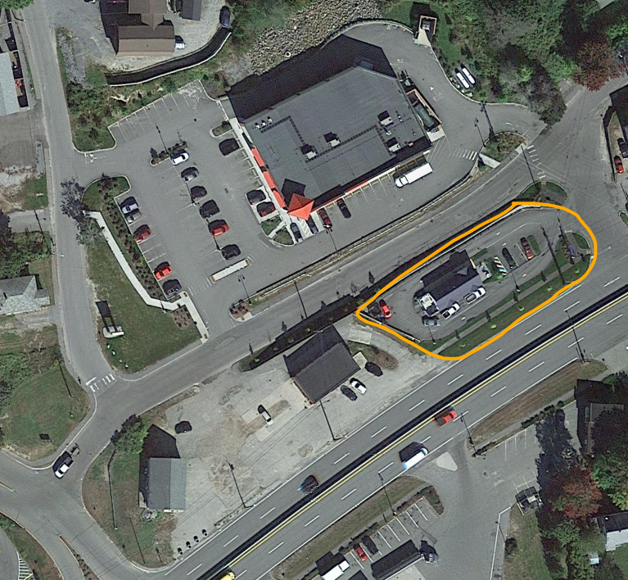
137 Leeman Highway contract zone Huse School contract zone reduced density
Allowed this very narrow site to be requirements to allow more apartments to make
Developed – without contract zone, the reuse of this school possible
would remain vacant.

More Examples

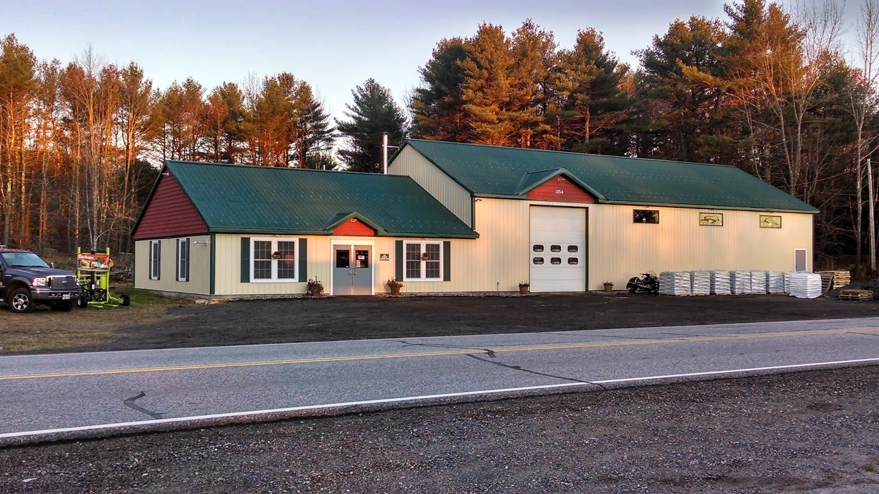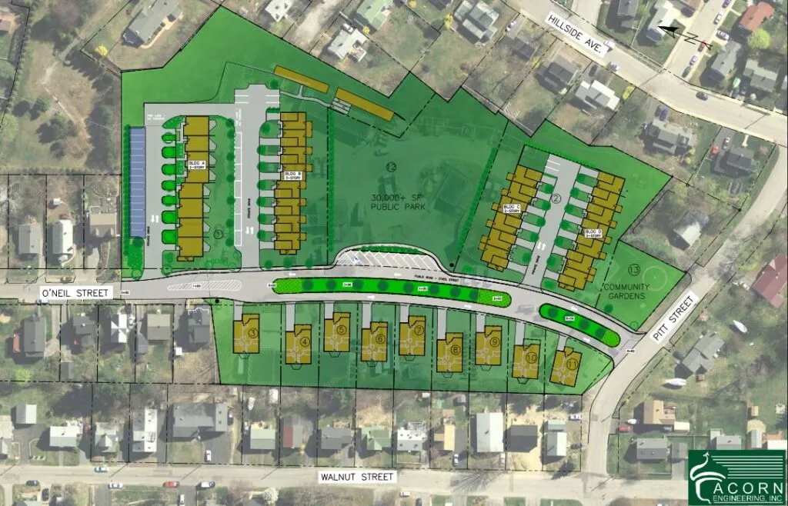
Southern Maine Renewable Fuels, Windham: O’Neil Park, South Portland:
Reintroducing a commercial use in a long-vacant allowed apartments/attached homes in a district where multi-
property in a rural residential zone. Business was family was not allowed. Terms include park and community
low-impact and compatible. garden on site and affordable units.

Cautions

Avoid spot zoning:
When a small parcel of land is singled out for special and privileged treatment and the singling out is not in the public interest but only for the benefit of the land owner, and the action is not in accord with the comprehensive plan.
Avoid serial contract zoning:
Contract zones are for individual, unique instances, not area rezoning. Don’t put a contract zone on one neighboring property at a time instead of rezoning an area.

Respectfully Submitted: ____________________________
Lisa B. Smith, Planning Board Secretary
Date Approved: March 28, 2024

