Town of Lisbon
Mark Stevens
Lisbon Parks & Recreation Director
18 School Street
Lisbon Falls, ME 04250
(207) 353-2289
mstevens@lisbonme.org

TO: Glenn Michalowski; Town Manager
SUBJECT: August 2023 Report
DATE: September 3, 2023

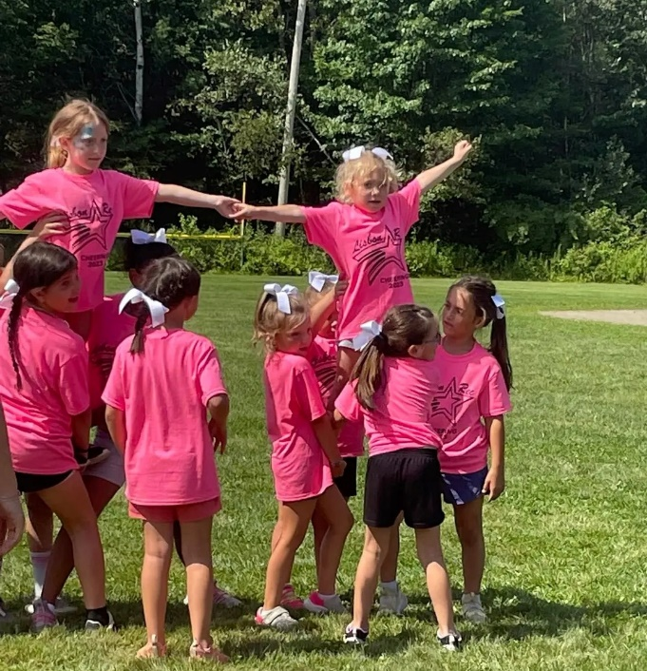
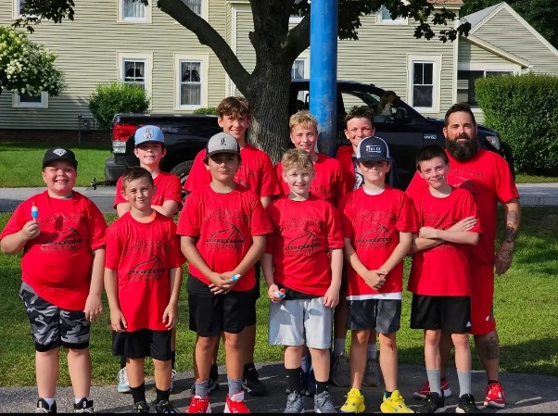
August flew by. Our Summer Day camps celebrated their last few weeks with many memories made. Soccer and basketball camps were held by Coach Shaun Fleck who graciously stepped into this role when our previous coordinator had to step down. Coach Fleck and our summer basketballers also flexed with us when initial plans to use the LHS gym fell through and they transitioned to an outside camp. Camp ran for two weeks with three different age groups, and our players exited camp stronger and more skilled than when they entered!

We’re also pleased to welcome Coach Sydney Douglass to our summer staff, offering a two week camp for Cheer to grades K-8. Lisbon’s cheer program has slowly dwindled and the response to Coach Sydney’s camp was astonishing. We hope to be able to offer more with her in the future!

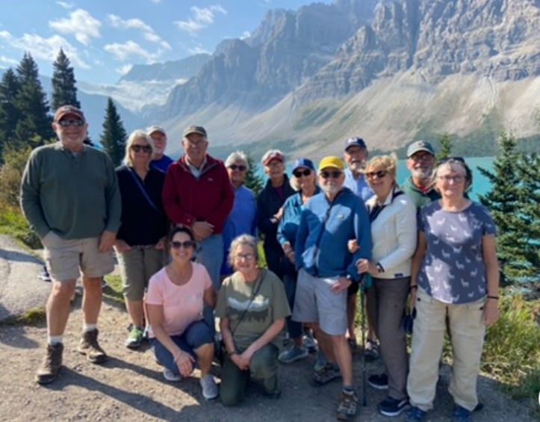
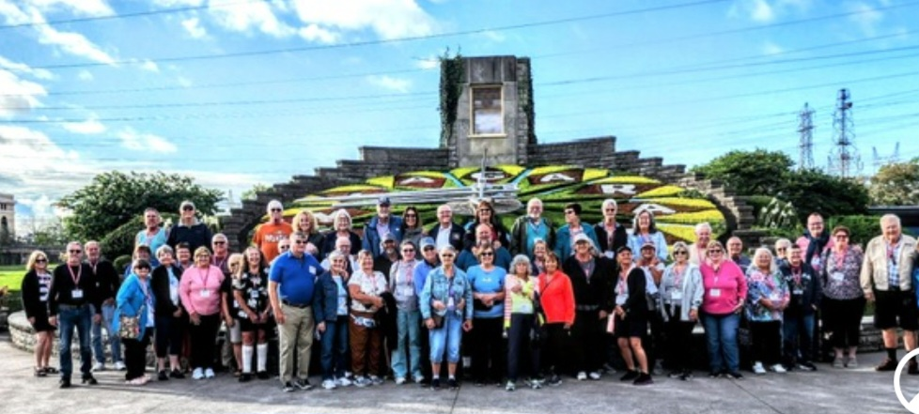
One of the absolute highlights for our department this month was the trip the Sunshine Hill Seniors took to the Canadian Rockies. No one was expecting how magical and breathtaking this trip was, and Aline is already saying they have to go back – after almost two weeks away, no one wanted to go home! We thank her and congratulate her on bringing delight and joy to our senior population by planning and executing such a memorable experience.

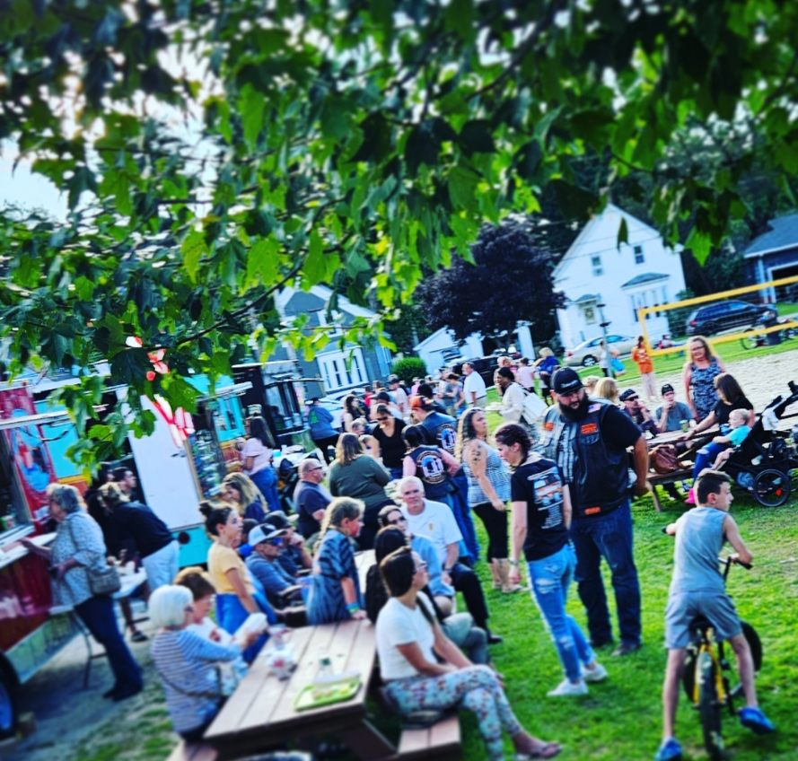
It is always the pleasure of the Parks & Recreation department to join forces with our local PD for D.A.R.E programming, and we had a blast once again planning and celebrating National Night Out (NNO) on August 1st for hundreds of our families and community. Officers Renee Bernard and Brianna Kenney teamed up with Kate Madore to offer games, giveaways, music, and food, and more to bring all of our public safety officials together with our families to get to know each other and celebrate.

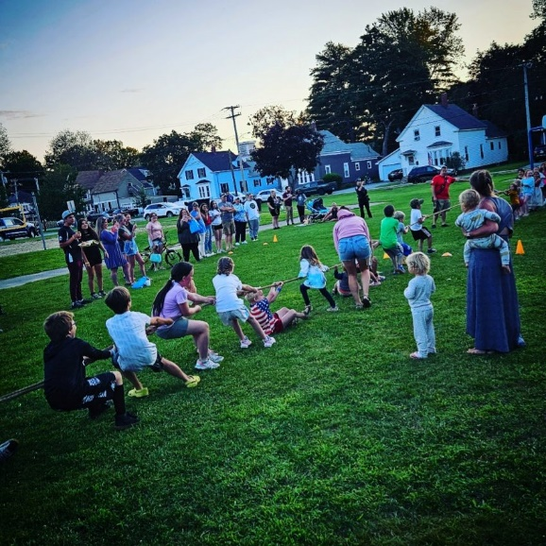
Throughout August we have put the finishing touches on our fall programming, including reserving fields and facilities, setting schedules, hiring officials, mowing, painting, and more to ready our players for fall Soccer, Field Hockey, and Football, as well as our ever-growing number of after school children for After School Rec. Recruiting coaches is an ongoing task – we have many dedicated, hard-working volunteer coaches and are always in need of more. Our recreation committee is debating offering a fee waiver for coaches who are willing to commit to the season to show them our gratitude, and this will be determined by committee at a later date.

Our parks crew continues this month to be busy repairing trails, installing signs, and maintaining our parks, grounds, trails, and cemeteries. We would like to thank Dean Logan for his hard work in re-installing a monument along the River Trail that was desecrated two times, spending hours to clean and repair it and replace a third time with enhanced safety measures, to ensure the family that commemorates this loved one can see it cared for for years to come.

