Town of Lisbon
Mark Stevens
Lisbon Parks & Recreation Director
18 School Street
Lisbon Falls, ME 04250
(207) 353-2289
mstevens@lisbonme.org

TO: Glenn Michalowski; Town Manager
SUBJECT: June – July 2023 Report
DATE: August 13, 2023

Our department barely sleeps over the months of June and July to prepare for and host the Moxie Festival. This year’s festival, 3 Days of Peace, Love, & Moxie, was by all accounts a happy success and brought much joy to the tens of thousands who attended. From expanding the festival to a true three-day offering to having it take place throughout town, culminating in two fantastic shows of the highest-quality talent at Beaver Park on Sunday, we are grateful to the untold hours of our incredible staff, volunteers, public safety, public works, and all town departments without whose support this event, which celebrates the spirit of our families and community, would never happen.

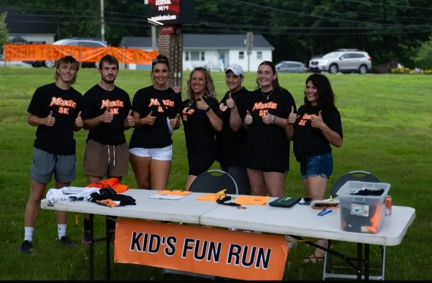
As much as we love the Moxie Festival, our greatest work of the summer is the care of our Summer Rec campers. We were privileged to host over 325 kids in our Summer Day Camps, the most we have ever had; through the hard work of our incredible staff, we kept joy and laughter as the most important thing during some long days, long bus rides, and lots of rain. Thank you is not enough to the work of our Summer Day Camps Coordinator, Supervisors, Assistant Supervisors, and Counselors. We went from York to Augusta and everywhere inbetween! We hosted friendly rivalries, field days, big screen movies, dance parties, and so much more. Thank you to Aline and the Sunshine Hill Seniors for sharing space all summer, to our friends at Midcoast Hunger Prevention who worked with us to procure food, and to the donors at Full Plates, Full Potential, who received our last-minute grant request to procure refrigerators, other food service items, and additional funds toward food for our campers who might not qualify for free/reduced meals! It took more than a village and we were sad to put an end to a wonderful summer.

June launched the Little Styx Field Hockey summer camp, and July hosted our football boot camp to prep for the fall season. It should be noted that our football campers loved the experience so much that camp continued far beyond the scheduled week while the boys went all-in for the pigskin.

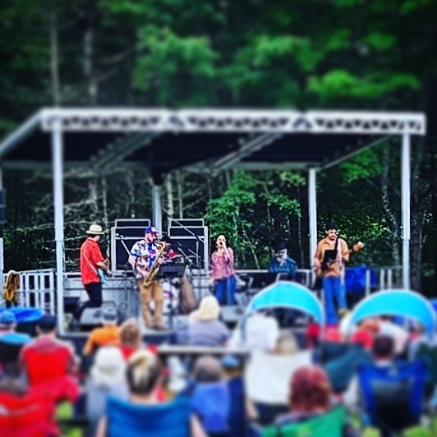
Our parks crew staff was instrumental in all of the above, maintaining grounds and facilities throughout the festival and camps, dealing with mower and equipment repairs while dodging raindrops to mow through the rainiest summer in recent history, and making sure Beaver Park was ready for the multiple groups that used it, including scouting groups, the Maine forest service, and inland fisheries and wildlife.

