Town of Lisbon
Mark Stevens
Lisbon Parks & Recreation Director
18 School Street
Lisbon Falls, ME 04250
(207) 353-2289
mstevens@lisbonme.org

TO: Glenn Michalowski; Town Manager
SUBJECT: September 2023 Report
DATE: October 3, 2023

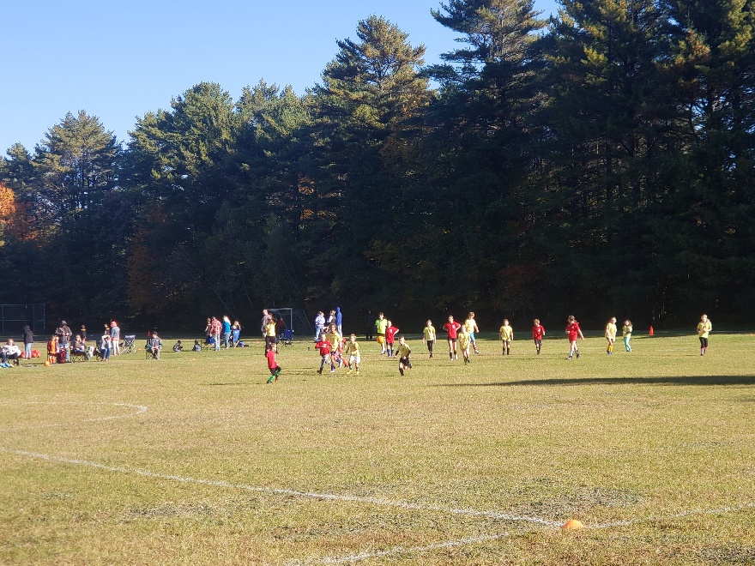
We love the growth of our department and are happy to welcome Holly Campbell aboard this month as our new Fall Soccer Coordinator. She has stepped into this role with confidence and ease and is already making us more organized for next year. We have many new parents stepping forward to coach our expanding lineup of teams as well and we look forward to them participating in our programs for years to come.

We’re also thrilled at the expansion of our Little Styx field hockey this fall, which has so many girls playing it necessitates running three full teams, (with goalies training in full goalie gear) and five coaches offering their time and skill to our enthusiastic players! Lisbon Parks & Recreation continues to run the Philip W Sugg Middle School and Football teams. Coaches Renee Bernard and Stephanie weeks have led their middle school girls to several wins this season, even while facing severe transportation issues to away games.

Thanks to Dan Leeman and a small army of football coaches, our football program is at or past capacity with more players looking to sign up all the time. We have heard from many community members as well as visiting teams how kind and engaged our coaches are with the players. Kudos to all our coaches for offering demonstrated sportsmanship alongside skill and athleticism.

The Sunshine Hill seniors traveled once again this month for a week in Niagara Falls! Aline didn’t miss a beat in flawlessly ending one trip and beginning another, all the while keeping regular day trips, programming, and meals going at the MTM.

After School Recreation has had so many sign ups that the school has to send two busses to bring everyone. We continue to play outside while the weather holds, thanks to our after school staff who care so deeply for their kids and their very important, often unappreciated, work. Also at the MTM we’re extremely lucky to offer an additional class this fall from our incredible Yoga instructor, Sara Helman, who has taken over the Tuesday 5:30pm class. Zumba led by Casey Alves continues this fall, and we were happy to coordinate with Linn Morin to expand her senior aerobics class to become Silver Sneaker certified.

The MTM had several other changes this month: our long-time custodian, Candace Williams, stepped down for other adventures in her life. We thank her with all of our hearts for her years of service lovingly caring for our space. Our department has been lucky to find a local cleaning service willing to take on our space and make the building shine even more. In the office, we are navigating two large changes with the payroll system being taken over by a different company and major updates to our primary system, MUNIS. Our staff has rolled up their sleeves to the challenges and is putting in the time to learn our new methods through and through. Even our recreation committee might see a few changes, with positions becoming vacant and a couple of new interested parties.

Beaver Park was home to the Town of Lisbon employee appreciation lunch this month, thanks to all who worked extra to make that happen. We had the Town of Sabattus at the park to complete canoe and kayak training this month, as well as our Lisbon athletes Cross Country team resuming practices along the trails. The Parks fleet of vehicles went through several upgrades, and our staff worked through several additional mandated trainings, while juggling their regular duties. Our thanks to them as well for cleaning and clearing Graziano Square park when The Dempsey challenge came to town and asked for use of the space at the end of September.

