PLANNING BOARD MINUTES

JANUARY 25, 2024
Shaun Carr, Chair– Regular 2024
Nicholas Craig, Vice Chair– Regular 2026
Dan Leeman- Regular 2025
Christopher Huston– Regular 2025
Patrick Maloy– Regular 2024
William Kuhl- Associate 2024
Natalie Thomsen – Associate 2025

- CALL TO ORDER: The Chairman, Mr. Carr called the workshop to order at 6:00 PM.
- ROLL CALL: Regular members present were Shaun Carr, Chris Huston, Patrick Maloy, Nicholas Craig and Dan Leeman. Associate Member William Kuhl was present as well. Natalie Thomsen was excused. Also present was Mark Stambach, Code Enforcement Officer; Glenn Michalowski, Town Manager, Fern Larochelle and Jo Jean Keller; Town Councilors; Kate Burch and Ben Smith, Town Planners and 24 audience members.
- WORKSHOP – ROS (Rural Open Space) I & II
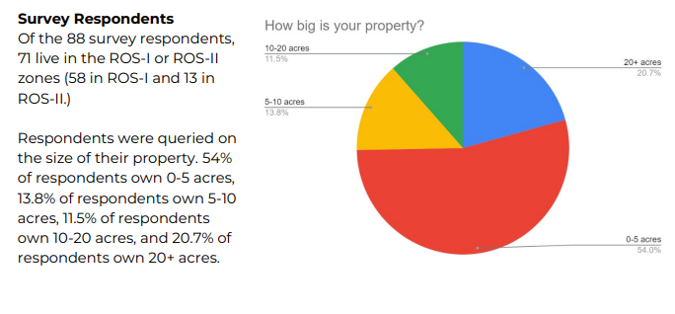
North Star Planning prepared a 9-question online survey to get input from the public on rural and open space land use in Lisbon, including zoning, current uses, plans for the future and the overall desire for preservation vs growth. The survey was available online from December 5, 2023 through January 18, 2024. The Town of Lisbon publicized the survey via their website and Facebook. 88 people responded. The following are results prepared by Northstar:

- REVIEW OF MEETING RULES:
The Chairman explained the meeting rules are located in the folder on the wall.
- WRITTEN COMMUNICATIONS: Minutes of , 2024
The meeting minutes were distributed to all the members. The Chairman asked if there were corrections or additions.

VOTE: (2024-) Mr., seconded by Mr. Carr moved to approve the Minutes of , 2024.
Vote: 4-0 Carried.
- PUBLIC HEARINGS –

6. UNFINISHED BUSINESS -

Of the respondents who live in the ROS-I and ROS-II zones, the majority of respondents own 0-5 acres, followed by 20+ acres.
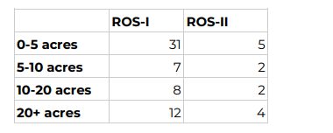

Balancing Preservation and Development
Respondents were asked, on a scale of 1-5, “How concerned are you about protecting Lisbon’s farms, forests, and open spaces from future development?” (1 –not at all, 5 – very concerned.) The average rating was 4.3.

Of respondents living in the ROS-I or ROS-II zones, the average rating was slightly lower, at 4.25. ROS-I residents’ average was 4.5 and ROS-II was 4.
Respondents were asked, on a scale of 1-5, “How much housing development should be allowed in the rural parts of Lisbon?” (1 –none, 5 – as much as people want to build.) The average rating was 2.4.

Of respondents living in the ROS-I or ROS-II zones, the average rating was the same – 2.4. ROS-I residents’ average was slightly lower at 2.2, and ROS-II was slightly higher at 2.6.

These results show general agreement that protecting agricultural and open space in Lisbon is a high concern for all respondents, and the desire for new housing in these areas is limited. Those in ROS-II, where there are the most zoning regulations that limit new housing, were slightly more interested in allowing new housing.

Land Uses
Respondents were asked how they currently use their land. The majority of ROS-I respondents only use their property for residences. In ROS-II, most properties are used both as residential and agriculture, conservation easements, or woodlots.
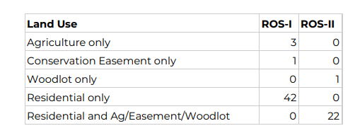

Respondents were asked about their plans for their land in the future. Overall, all but 3 survey respondents said they plan to keep using their land in the same way. Those 3 respondents all live in ROS-I and currently use their land for agriculture only. 2 respondents (one who owns 0-5 acres and one who owns 20+ acres) said they are “not sure” how they will use their land in the future; 1 respondent who owns 20+ acres wants to use his land for residential development in the future.
_____________________________________________________________________________________________

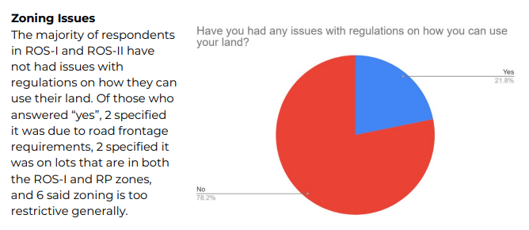

Interest in Easements
Respondents were asked, “Would you be interested in enrolling in a tax program or conservation easement to lower the tax burden on your property?”

Of those living in ROS-I or ROS-II, the majority said they might be interested. About 10% of people are already enrolled, and about 20% said yes, and 20% said no.
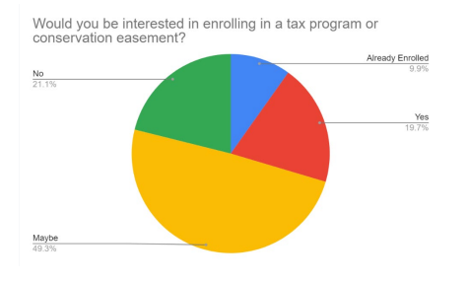

_____________________________________________________________________________________________

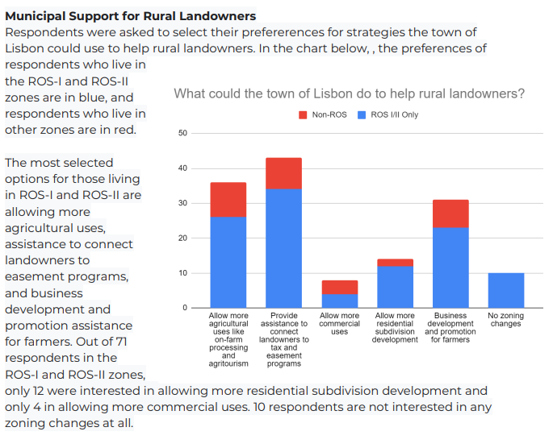
Mr. Smith explained the part of the zoning map in the North eastern part of town where there was is a lot of open/forested land which is currently zoned Rural Open Space I and II. The planners are currently thinking of this space based on the existing land use, the proximity to Lisbon Falls and the Village, and in the context of how the land is being used today. He said the community has a lot of tools when thinking about regulating land use, encouraging certain activities and discouraging other activities, zoning being one of those. He said zoning boundaries are important to consider when looking at the different areas and how the zones are laid out. Mr. Smith said there’s been discussions at various Planning Board workshops regarding the differences between ROS I & II and would it be easier to think of those two areas as one place. He said zoning and dimensional standards around lot frontage, lot sizes and how many houses can be located on a piece of property of a given size are all part of zoning as well. He also said subdivision standards are part of zoning and land use ordinance as well. How properties are divided can impact the character of an area, not just about the number of houses but how they are laid out and how they relate to each other, thinking about the proximity of those houses to each other, to existing houses and to the roads. Updating road standards comes into play as well when constructing new roads. The planners try to limit the size of new roads so they’re not overbuilding for the amount of traffic that has environmental and storm water impacts.

Mr. Smith also talked about Land Use changes stating towns have open space plans documenting places that are important, places to protect and preserve from a Habitat/Economic and Recreational standpoint. He said the other thing to think about is how can the Town support existing farm business’ to help them to continue to be profitable and to continue to be able to use the land as they are using it today. Mr. Smith said the survey results around easements made him think that there is a lot of potential interest in open space, farmland/tax credits and easements, but only 10% of respondents had gone through the plan. He thinks the Town could to help citizens go through that process to benefit more.

Ms. Burch stated ROS I has about a 2-1/4 acre minimum lot size, requiring 300 feet of street frontage and are required to do an open space subdivision if your parcel is over 10 acres. She said in ROS II, the minimum lot size and road frontage requirements are the same but there are more restrictions on new housing. No new residential subdivisions, backlots and all new lots must have driveways onto existing public streets. She said the reason for all the zoning regulations is to protect the ruralness of Lisbon.

Ms. Burch explained that Lisbon currently has Open Space Subdivisions standards which require that when someone wants to divide a piece of land, at least half of the land has to be permanently conserved for open space/farmland/woodlots etc. and the other half would be for housing. She said typically these subdivisions allow the applicant to play around with the lot size and dimensional requirements in order to make a more creative design that allows for maximization of the best parts of the open space like the best soils etc. There is also requirements to create a visual buffer from the road to preserve the rural views.

Traci Austin, 72 Webster Road, Lisbon talked about her concerns with the growth of Lisbon with new housing coming in. She said that rapid growth can cause lack of forethought in rushing the process and overlooking the fact that bringing families into Lisbon, services need to grow, schools need to grow, which means additions and staff for all town agencies.

Roger Cote, community member and prior Planning Board and Council member asked how the changes to ROS I & II would affect the Comprehensive Plan. Mr. Kuhl said the Comprehensive Plan will not be affected by these changes. The rural areas will stay rural, they are just changing how they regulate the areas.

Eugene (Charles) Smith, 18 Free Street, Lisbon said the map of Lisbon is not correct for his property line. He presented the Code Enforcement officer with a correct map. He stated he would favor the maximum lot size but wouldn’t mind seeing the lot sizes, especially the frontage reduced.

Arthur Kesaris, 216 & 224 Ridge Rd. Lisbon said he and his brother came to the Planning Board a couple years ago to try to split his 50 acre parcel which the Board helped him with. He said in the future, he’d like to be able to deed a piece of property to family members but does not want to jump through hoops to make that happen. He feels like ROS II is too restrictive.

Vince Carrier, 24 Bowdoinham Rd. Lisbon Falls asked if lots come up for sale in ROS I & II, will they be single family homes or will they allow multi-family homes. Mr. Kuhl said that most applications coming in are for single family homes since multi-family homes are often limited due to the lack of central water and sewer.

David Bowie, 140 Upland Rd. Lisbon said he is in ROS II and cannot subdivide his land. Mr. Bowie suggested that if the Town mixes in housing with rural farmland, they should make sure there is a buffer zone between the agricultural and residential uses. He also suggested not applying changes to the entire group of ROS all at once because it could lead to a bottleneck along the way. He asked if the lots are big enough to support having a well and septic field on the same small lot.

Patricia Suthers, 65 Gould Rd., Lisbon Falls, said she lives on a back lot with a right of way to her property. She has about 48 acres with 38 acres being in tree growth. She said she has a fairly small house on the lot. Her son would like to build a house but was told it was not allowed because she does not have road frontage. Her son lives on Gould road and has a 4+ acre lot. She suggested taking some land from his lot to create a driveway up to her lot, but was told she could not do that. She said she’s not looking to put in a subdivision and values her property, but would like to have family close by as she get older.

4. PLANNING BOARD MEETING – The Planning Board Meeting began at 7:05pm.

5. CHAIRMAN’S REVIEW OF MEETING RULES

- WRITTEN COMMUNICATIONS- Minutes of January 11, 2024
The meeting minutes were distributed to all the members. The Chairman asked if there were corrections or additions.

VOTE: (2024-06) Mr Craig, seconded by Mr. Maloy moved to approve the Minutes of January 11, 2024.

- PUBLIC HEARINGS – Case #24-01- Conditional Use Application- Cutler’s Rear Lot

The Chairman opened and closed the Public Hearing with no public comment.

- UNFINISHED BUSINESS- A. Case #24-01- Conditional Use Application- Cutler’s Rear Lot
Charles Cutler
264 Main St
Lisbon Falls, Me 04252
Map R2 Lot 16

Mr. Stambach went through the Conditional Use Standards and Local Ordinance Checklists.

VOTE: (2024-07) Mr. Maloy, seconded by Mr. Craig moved to approve the application for Case #24-01 Conditional Use- Cutler’s Rear Lot.
5-0 Carried.

B. Findings of Facts Case #23-21- Site Plan Application – Self Storage Expansion
C. Findings of Facts Case #22-22 – Site Plan Review Application- Outdoor Storage Yard

VOTE: (2024-08) Mr. Craig, seconded by Mr. Maloy moved to table the Findings of Facts for Case #23-21 and Case #23-22 to the next meeting to be able to review information submitted from the Town Attorney regarding the Outdoor Storage Yard definitions. Vote: 5-0 Carried.

- NEW BUSINESS – Case #24-02 Subdivision Review Application – Crafts Property
Dan & Michelle Oram
9 Moxie Lane
Lisbon Falls, Me
Map U3 Lot 25-A & 25-C

Jay Raitt, from Little River Land Surveying, representing the applicant stated the applicant would like to convey part of their property to their daughter.

VOTE: (2024-09) Mr. Craig, seconded by Mr. Maloy moved to accept the application as complete and schedule a Public Hearing for February 8, 2024. Vote: 5-0 Carried.

- OTHER BUSINESS –
- ROS I/II Workshop Discussion/Debrief
Mr. Carr said the Workshop was well attended and he was pleased to get feedback from the public.
Mr. Craig thanked Northstar Planning for their hard work in putting together the information and presenting it to the public.
Mr. Smith said the survey results show that there is a consensus about this part of town remaining rural which gives them a starting point as well as how new development will look like and what minor adjustments need to be made.
Mr. Huston asked if it were possible to make changes and not call it a subdivision since property owners are just trying to branch out a couple of acres at a time. Mr. Maloy said he heard from community members who feel the same overwhelming pressures of changes coming up when the word subdivision is talked about since it is a restrictive process.
- Planning Board Workplan
- Planning Projects
Ms. Burch presented the Planning Board with a list of projects that have been discussed with the Board and other Departments and to think about what should be top priorities to work on in the future and to see if they had any other items they want to add.
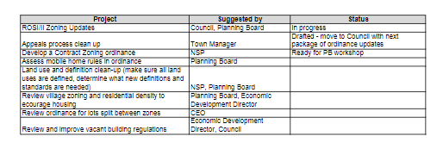
- Discussions of inconsistencies of the Resource Protection District and the Shoreland Zone Maps
VOTE: (2024-10) Mr. Craig, seconded by Mr. Leeman moved to table this discussion till the next meeting to allow the Code Enforcement Officer time to gather more information. Vote: 5-0 Carried.

- CODE ENFORCEMENT OFFICER – NONE
- ADJOURNMENT
VOTE: (2024-11) Mr. Maloy, seconded by Mr. Craig moved to adjourn at 8:15 pm. Vote: 5-0 Carried
Respectfully Submitted: ____________________________
Lisa B. Smith, Planning Board Secretary
Date Approved: February 8, 2024

