Town of Lisbon
Mark Stevens
Lisbon Parks & Recreation Director
18 School Street
Lisbon Falls, ME 04250
(207) 353-2289
mstevens@lisbonme.org

TO: Ryan McGee; Town Manager
SUBJECT: August 2022 Report
DATE: September 14, 2022

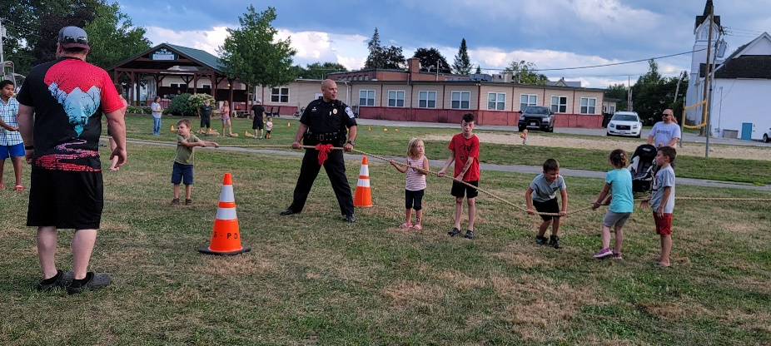
Although the Moxie Festival was over, August did not slow down for our department. We kicked off the month on August 2 by partnering with LPD for National Night Out, held at the MTM Park. We had a great turnout for free hot dogs and other refreshments, music, games, demonstrations, and more. Special thanks to the fire department for the cool down in the sweltering heat with their water cannon!

Our Summer Day Camps ran through the first part of the month, visiting several more state and amusement parks on field trips. We ended the year with a slideshow of our summer fun and talent show attended by many families. With a total of 275 children and their families served this summer, we would like to thank our incredible staff who gave 110% for their campers every day, as well as Mid-coast Hunger Prevention Program that helped us feed breakfast, lunch, and snacks to these kids all summer.
The Sunshine Hill Seniors program has continued to see an increase in membership, with Friday morning breakfasts reaching full capacity and even selling out! Aline continues to plan both day trips and re-institute longer bus and overnight trips that have been on hold since prior to the Covid pandemic. Plans for the fall include a leaf-peeping train trip, a bus trip to Atlantic City, and a book club is in the planning stages.

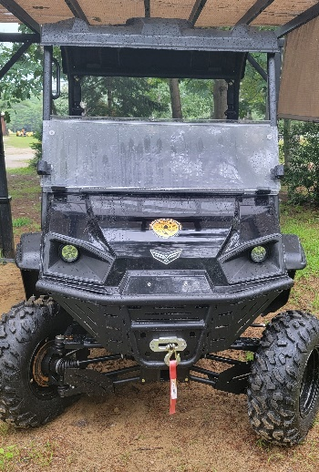
In August, we completed our purchase of a UTV for Beaver Park trail keeping and maintenance. We gained a new full-time year-round employee with the hiring of Dean Logan for Parks Maintenance this month. Dean comes to us with decades of experience in automotive repair and all-around maintenance. Welcome to the Parks & Recreation Department, Dean, we can’t wait to see what the future brings.

To wrap up the summer, we brought back Movies in the Park this month on Friday nights, August 12, 19, and 26. About seventy-five people enjoyed free full-screen viewings of classics like The Princess Bride projected onto the MTM Pavilion. We hope to offer theses evenings to even more families next summer.

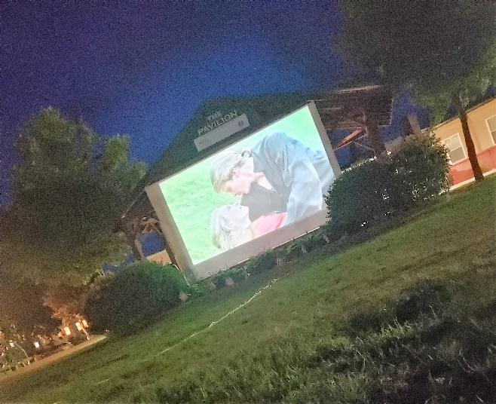
August opens registrations for all of our Fall programs, and we daily registered players for Flag, Pee-Wee, Youth, and Tackle Football; Little Kickers and K-6 soccer; Little Styx Field Hockey, PWS Middle School Field Hockey, and Before and After School programs, as well as offering two-week prep clinics for basketball and soccer for three different age levels throughout the month. The Track & Field program ended the second week of August and we are proud of multiple Lisbon athletes who placed at the State Meet at Cony High School on August 13th.

Our Moxie wrap up meeting went late into the evening on August 18th. Almost the entire Moxie Committee was able to attend, as well as several new members. We discussed what went well for the return of the festival this year, as well as ways to improve for 2023. The minutes for this meeting are available separately. A workshop is scheduled for early October with the Town Council.

