Town of Lisbon
Mark Stevens
Lisbon Parks & Recreation Director
18 School Street
Lisbon Falls, ME 04250
(207) 353-2289
mstevens@lisbonme.org

TO: Ryan McGee, Town Manager

SUBJECT: February 2022 Report

DATE: February 10, 2022

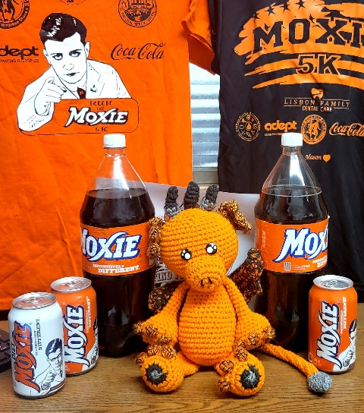
As reported last month, the Moxie Festival Coordinator position was posted at the beginning of January without any formal applicants. As February progressed it became clear that no applicants were coming forward. As the announcement of the Festival garnered a generous amount of local and national media, and the time to move forward with planning was imminent, the decision was made and approved by the council that Aline and Kate from our department would formally take on Coordinator responsibilities. They have jumped in with both feet and are making daily progress on reaching Festival checkpoints early and thoroughly.

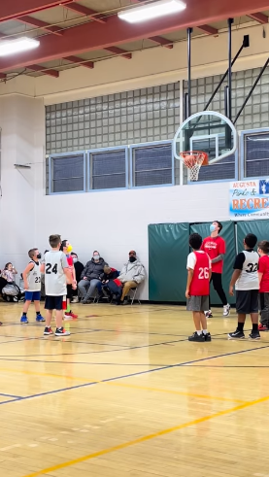
The Moxie Committee met formally during the month of February, the highlight of which was connecting with the L/A Chamber and Uplift L/A. Although each coordinator presented their updates at the meeting, to mention this does not give the whole story. Our coordinators have been connecting weekly and even daily with Aline and Kate to keep pushing the dates forward for the festival.

As mentioned above, local and national media were quick to pick up on the Festival’s return. More than 40 media outlets across the country carried the story, along with the Moxie soda shortage that Moxie lovers had been experiencing since the fall, and in early February National Public Radio called our office for an interview of our take on all things Moxie. Our Department was featured on the NPR Weekend edition February 5th/6th.

Regarding our winter programs, Ski/Snowboard wrapped up this month. Basketball was in full swing, and we were grateful for Julie Collins efforts to return this to a travel league. Participants are having a great time, and we are grateful to our volunteer coaches, officials, and parents, who have navigated the continually changing covid regulations that vary from school to school and gym to gym. Our department did everything we could to get Winter Swim resurrected in February working in conjunction with the Lewiston Y, but ultimately due to the bus driver shortage we were unable to get transportation for our students to the pool.

Jordan Schanck ended his time with the Parks and Recreation department this month. We thank him for his time with us and wish him well in his next venture.
The LPD/Lisbon Rec skating party that was prepared and advertised for February 12 was postponed to February 19 due to rain, and then had to be canceled on the 19th due to a 60 degree day the week prior that ruined the ice, much to our disappointment.

On the parks front, we are beginning cleanup as the snow banks recede and identifiying areas where brown tail months are nesting, to remove as many of these as possible before hatching in April.

Aline’s seniors continued to have delicious lunches throughout February. She is looking to bring back breakfast once more in March. The seniors enjoyed several trips this month, and Aline is planning the return of an overnight trip later this year, and already has tickets to the Red Sox in the works.

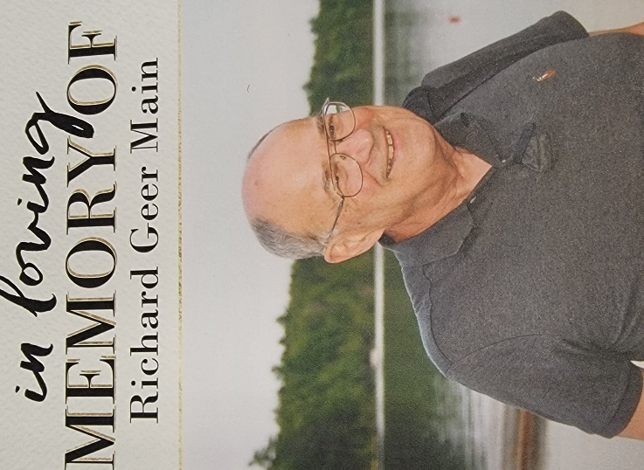
Our After School program continued to pick up several new students in the month of February, and Jennifer Willey is doing an amazing job keeping her staff well trained and making safe fun and memorable activities for the many children entrusted to our care every day.

It is with a heavy heart we share the passing of our longtime friend and Conservation Committee member Richard Mains in February. He was a ceaseless advocate for our department and our town as a whole.

