Town of Lisbon
Mark Stevens
Lisbon Parks & Recreation Director
18 School Street
Lisbon Falls, ME 04250
(207) 353-2289
mstevens@lisbonme.org

TO: Diane Barnes; Town Manager

SUBJECT: January 2022 Report

DATE: February 10, 2022

We have posted the Moxie Festival Coordinator position in early January. We have not had any formal applicants, however, I have spoken to several people who work in Lisbon about the position and all the details the job encompasses. Everyone I spoke with felt it was just too much to take on and run a business, especially as things get busy in the warmer months. We have to keep moving forward with the plans as we continue the search. Thankfully, Kate and Aline have been receptive to moving the planning process forward for now.

A car driven by an elderly man drove straight through our wonderful Wheel Garden in January. This is the third time someone has missed the slight turn toward the stop sign and drove through the park and knocked out our mill wheels. We purchased a new treadmill for the fitness center in January. We currently have 100 consistently registering month to month. We are expecting these numbers to grow even higher in February.

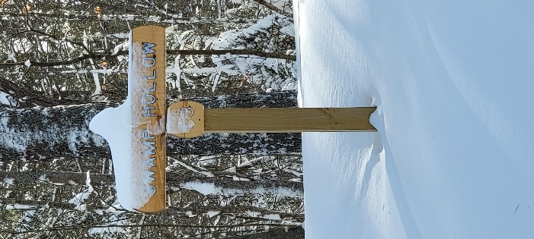
The month of January was one of the coldest recorded in recent history. Our snow fall was less than normal, so with that we could not offer our Annual Winter Festival. Our Lost Valley Ski program kicked off on the first Monday in January. We only have 20 people in the program this year, but we are pleased because it is a revival of a program that we lost years ago because of the steep lift prices. The new owners have reached out to us offering lower prices making affordable once again.

Youth Basketball is in full swing during the month of January. The participants range from K-6 grades. The practices are held Monday – Thursday and games are on Saturday at LCS. We also have 4 travel teams competing in tournaments in February. Julie Collins does a great job coordinating this program.

Senior Coordinator, Aline is back to making lunches and offering cribbage games again. Some folks just can’t get enough so recently we have the men come in to play cribbage on Wednesday and women play on Thursdays.

