Town of Lisbon
Mark Stevens
Lisbon Parks & Recreation Director
18 School Street
Lisbon Falls, ME 04250
(207) 353-2289
mstevens@lisbonme.org

TO: Ryan McGee; Town Manager
SUBJECT: June/July 2022 Report
DATE: August 10, 2022

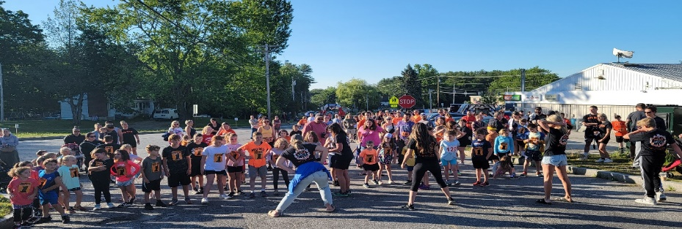
The first thing to express about June and July of 2022 is our appreciation for all our volunteers, staff, sponsors, and elected officials for supporting our department. We couldn’t do a thing without you all.

There is no way to capture the amount of energy, positivity, and hard work that was poured into the Parks & Recreation department during the months of June and July.

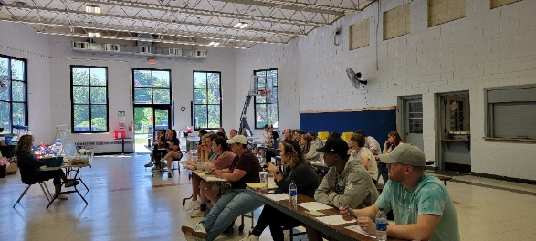
June flew by in a blur, as we were at full tilt in every area of every program plus some more. June saw the end of the school year and the closure of another successful year of our Before & After School program, which served over one hundred fifty children and their families. Immediately upon the heels of this program ending, we began hiring and training for our summer day camps. We would like to recognize Karen Durisko for leading one of our biggest programs of the year. She was involved with our training, planning, maintaining, and serving our staff and families. On two occasions we needed to close registration and take a wait list while we worked to hire more staff to keep our programs safe and effective. Ultimately we capped the program at 275, with thirty more children on a waitlist.

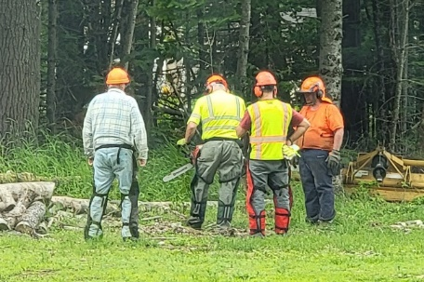
While this was happening, our department maintained and enhanced our gardens, parks, trails, and cemeteries keeping them beautiful for our citizens and all who come to Lisbon from near and far.

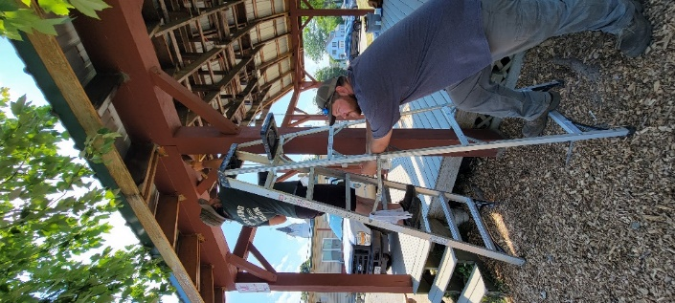
One of our missions for the month of June and July were to keep the hydro-seed at Worumbo park alive. We figured a way to pump water from the river adding several hundred feet of garden hose to the mix. The issue was that we just couldn’t get enough water on the area. We borrowed the school water cannon and asked for help from the water department and fire department for 3 inch hoses and access to the hydrant. This made a big difference pumping about 500 gallons per min to the 2 plus acres of space. The area is green, but not fully functional since the loam was not screened prior to getting spread. Top dressing should work to have it ready for Summer 2023 events. Our staff assisted in the setup of the Maine Blues Festival on June 18 and painted the MTM Pavilion in anticipation of a summer of usage. We also replaced the guardrail along the Miller Trail portion of the walking path. Parks staff also completed chainsaw and other safety training in this time. In July we posted for our new Parks Maintenance staff position and received many qualified applicants.

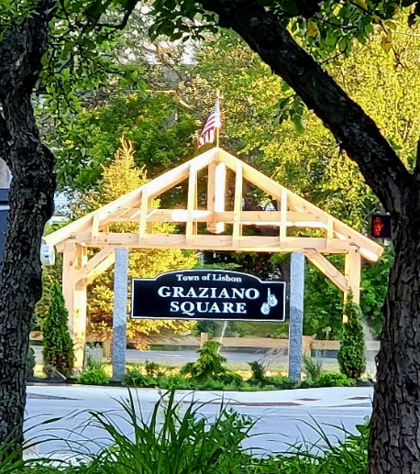
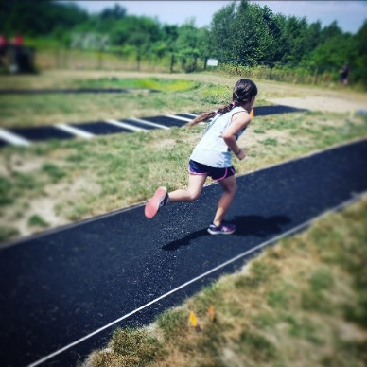
Recreation Track & Field, Little Styx field hockey, field hockey boot camp and Football camp also took place in June and July, preparing our young athletes for their seasons ahead. Moxie Cruise-In Nights on Monday continued to be popular with the exception of rain-outs, folks enjoying DJ Adam Normand and Cruizin Slice food truck.

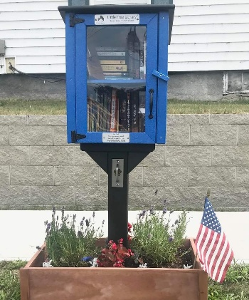
At Graziano Square, the long-awaited Gazebo was installed by Christian Madore and crew on July 4th. We are excited for the beauty and usefulness this structure will bring to our town, and seeing the park take its final shape. The Carlson family donated a mini library to Graziano Square in July!
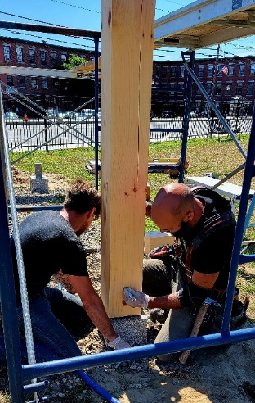
Concurrent with all this activity, our staff and incredible volunteers planned and ran the Moxie Festival, which was a source of enjoyment to tens of thousands over the three day course of events. Friday night events were exceptionally well attended and the fireworks show went off without a hitch. The Moxie 5K and Car Show saw an unprecedented number of registrants.

Our staff was interviewed by four tv networks and made an appearance on Frank FM and 99.9 The Wolf. Our beloved Moxie Parade once again returned as the best two hour traffic jam in the state, our vendors newly located at MTM had standing room only all day, and our lineup of entertainment was outstanding. More reports on the success of the Festival and planning for next year will happen at our follow-up meeting on August 18.
