Town of Lisbon
Mark Stevens
Lisbon Parks & Recreation Director
18 School Street
Lisbon Falls, ME 04250
(207) 353-2289
mstevens@lisbonme.org

TO: Ryan McGee; Town Manager
SUBJECT: May 2022 Report
DATE: June 15, 2022

May has been fever pitch with activity at the Recreation Department. With the beautiful weather returning, our parks crew has been nonstop readying cemeteries, gardens, parks, and trails for Memorial Day. We re-hired Jeffrey Arsenault to seasonal staff after his great work last year, and in addition hired Nicholas Jacques as a first-year parks seasonal. Both have jumped right in to get our town in ship shape for the summer. All gardens were cleaned up from winter, weeded mulched, planted, and mowed, stones and barriers reset, dog pot stations and trash cans reinstalled, portable toilets delivered, and on and on.

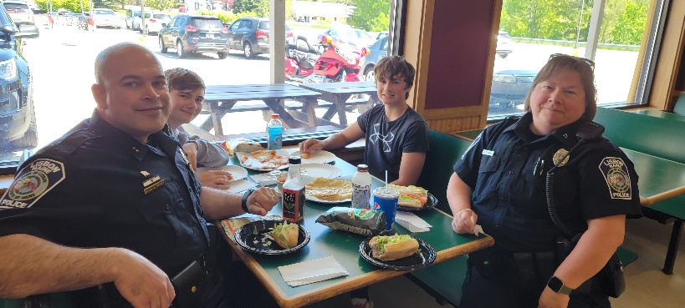
We celebrated our annual Kids-to-Parks Day and our fishing derby mid-May. A winner was randomly selected from all entries posted to our Facebook page, and enjoyed a lunch out with Police Chief/Interim Town Manager Ryan McGee, Office Renee Bernard, and Parks and Recreation Director Mark Stevens.

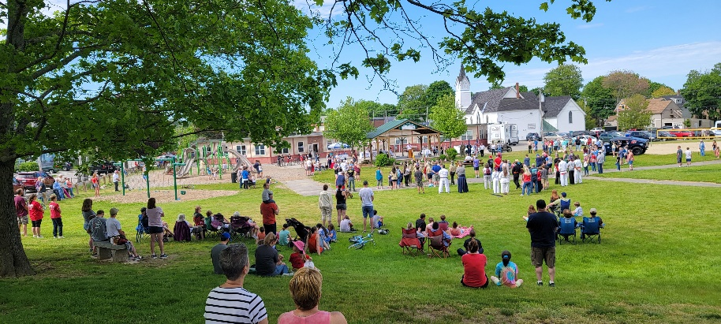
We continue to pour energy into summer planning. The sports program registrations have been steady, but summer camp registrations have exploded. Last summer (2021) we had a total of 189 registrations. At the time of this writing, we are at 240 registrations, with weeks left before day camps begin. We are recruiting more staff and drivers to ensure a safe, smooth, and fun summer for all.

The end of May saw beautiful ceremonies throughout town commemorating Memorial Day for all the fallen, especially our own citizens who never came home. We were grateful to collaborate with several civic groups, including Heidi Baird and her local girl scout troupe, to honor our military and their families.

Cruise nights also began again in May with a phenomenal kick-off May 30. We had upwards of sixty or seventy cars, and Jim Baumer on guitar providing music for a beautiful summer night at Worumbo.

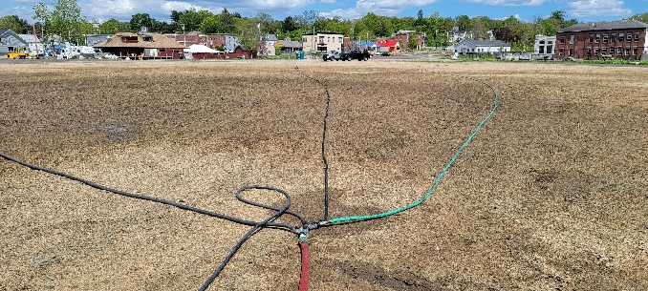
Speaking of Worumbo, our staff spent many hours here this month. The Parks crew visited every few hours to monitor and water the acre of hydro seed planted, and the entire Parks & Recreation department team spent a day at the site cleaning up and assessing its readiness for future gatherings. While we are currently joining forces with Public Works in preparing the site for the Blues Festival, after picking up bucketfuls of debris and navigating uneven terrain, we determined that some more work toward making it safe and accessible for all is needed to ready this space for future rental.
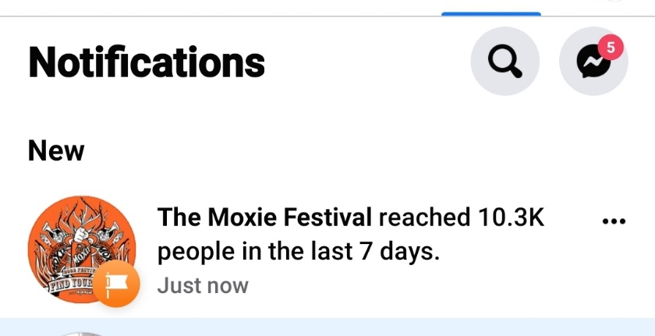
The Moxie Festival planning could be (and is) its own report. Co-coordinators Aline and Kate are working round the clock to iron out the many details that make this festival a success. We have moved to bi-monthly meetings and are excited about the celebration that is shaping up.

As the month wraps up, we are cleaning up the budgets for fiscal year end and budgeting and making goals for the year 2023 beginning July 1.

