Town of Lisbon
Mark Stevens
Lisbon Parks & Recreation Director
18 School Street
Lisbon Falls, ME 04250
(207) 353-2289
mstevens@lisbonme.org

TO: Ryan McGee; Town Manager
SUBJECT: September 2022 Report
DATE: October 13, 2022

We always welcome September at the Parks & Recreation department as a transitional time. At our parks, mowing needs slow down and we transition to fall cleanup and winter planning. In our recreation programs, we have buttoned up our busy summer and turn our focus toward our school year programming and fall sports.

The Sunshine Hill seniors saw the final arrival and successful completion of a trip delayed almost three years due to the pandemic, with forty folks traveling across the pond for an eleven-day stay in the beautiful, mysterious, and historic highlands of Scotland and Ireland. Kudos to Aline Strout for carrying the torch on this project for so long and its ultimate success. Although she was not able to physically be present, we know her care and detail were present in every moment of the trip and the wonder experienced by all.

Aline also participated in September in a summit for local senior coordinators, held in Bath. She came away with many insights into what other programs were doing, and we continue to be amazed by what our little town is capable of, as most of the Sunshine Hill programs – whether, travel, meals, fitness, and others – outpace larger towns with membership and interest. We are grateful to have such a thriving senior population participate in our community and gift their presence and wisdom to all they encounter.

In September our department advertised and hired for a new position, Assistant Director. Kate Madore was selected to fill this role, moving on from the positions she has held at the department for over two years as Administrative Assistant and Moxie Festival Co-Coordinator. Kate knows intricately the workings of our department and we are excited to continue to grow with her enthusiasm and energy in this new capacity.

This month we have the following activities begun: Before School care, After School care, Little Styx Field Hockey, Middle School Field Hockey, Flag Football, PeeWee Football, Youth Football, 7/8 Tackle Football, Little Kickers Soccer, K-2 Soccer, and 3-6 Soccer. This represents around six hundred fifty program enrollments. We could not run these programs without our dedicated staff and volunteer coaches. Thank you to Lynna for running so many volunteer applications!

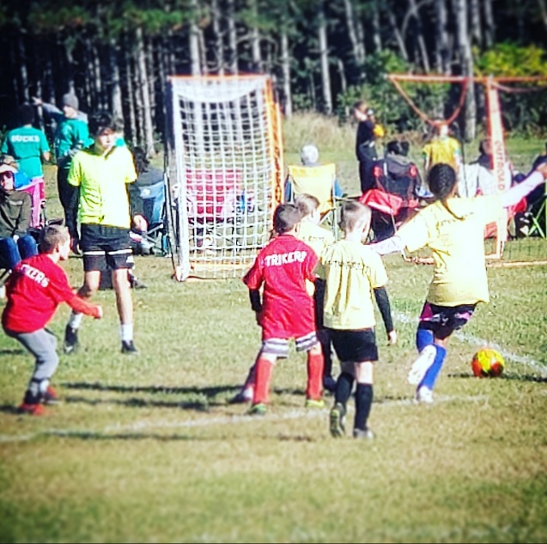
Beaver Park has been the epicenter of our Fall Soccer, with teams practicing or playing games seven days a week. We created two full-size fields, which we adapt for the littlest players. There is plenty of room for families to spread out and enjoy watching their athletes.

