
TOWN COUNCIL
MEETING MINUTES
July 11, 2023
lisbon town OFFICE
7:00 pm meeting
Harry Moore, Jr., Chair 2024
Raymond Robishaw, Vice Chair 2024
Mark Lunt 2025
Donald Fellows 2025
Jo-Jean Keller 2025
Christine Cain 2024
Fern Larochelle 2023

CALL TO ORDER. The Chair, Harry Moore, called the meeting to order and led the Pledge of Allegiance to the Flag at 7:00 PM.
ROLL CALL. Members present were Councilors Cain, Fellows, Keller, Larochelle, Lunt, Moore and Robishaw. Also present were Glenn Michalowski, Town Manager; Ryan McGee, Police Chief; Nate LeClair, Fire Chief; Ross Cunningham, Economic & Community Development Director; Bill Meakin, acting Library Director; Kristen Collins, Town Attorney; and approximately 5 citizens in the audience.
EXECUTIVE SESSION
Per 1 MRSA Section 405(6)(E) Consultation with Legal Counsel
and
per 1 MRSA §405(6)(C) Acquisition of Real Property or Economic Development
VOTE (2020-136 & 137) Councilor Larochelle, seconded by Councilor Cain, moved to go into Executive Session at 7:02 PM per 1 MRSA §405(6)(E) Consultation with Legal Counsel, and per 1 MRSA §405(6)(C) Acquisition of Real Property Or Economic Development.
Order passed – Vote 7-0.
VOTE (2022-137A) Councilor Larochelle, seconded by Councilor Fellows, moved to resume the regular meeting at 7:57 PM.
Order passed – Vote 7-0.
VOTE (2022-137B) Councilor Larochelle, seconded by Councilor Fellows, moved to approve a $400,000.00 loan to Blue Ox Malt House/Blue Ox Realty at 5% interest for a 5-year term, with renewal not to exceed 15 years, and to authorize the Town Manager to complete the appropriate legal documentation process to execute the transaction, based on the Revolving Loan Fund Committee’s review and unanimous recommendation.
Order passed – Vote 7-0.
OTHER BUSINESS
Public Safety Building Findings
Item taken out of order.
Andrew Hyland, a Principal of Port City Architecture, explained that they were hired almost a year ago to look at Fire and Police needs to come up with a feasibility study. He introduced his fellow consultants, Neil Courtney and Curtis Robinson. He said the company is an experienced Maine company, and said he would describe the step by step process used to vote or look for grants. He said this is condensed to a summary version and that a full version will be available.
Neil Courtney began with the fire Department highlights. He reviewed the Fire Department mission statement and said that so far the town has accomplished a great deal, including an allocated study, an ambulance on order, funding for pumps and much more. He offered an encapsulation of what he encountered during the study. Beginning with staff, he pointed out that in 1993 there were 70 firefighters. Now there are 31, including the Chief and 2 full-time firefighters. He said this is rampant in this sector, and sees that Lisbon has recognized that we are woefully behind, even with the recent hirings. He said that, emphasizing the needs of the town, growth will be coming. He said the Per Diem system is always changing, and doesn’t always work, and the next step is full time staffing.
Mr. Courtney went on to urge the Council not to leave the department in the breakdown lane. He said one thing that attracts firefighters is a new facility. He said LOWSAP (Length of Service Award Program) is a retirement program that may be another tool. And he explained that career personnel would augment the on-call components. He said that applying for grants is a segue for getting full time people and is an option to consider. He also said we should consider non-traditional students at vocational schools. He said that we don’t have that in this area, but it could be collaborative employment.
Mr. Courtney said that a lot of his recommendations are based on NFPA standards. He commended Lisbon for the vehicle replacement program, he said it is stellar. He suggested we hold onto the newest “old truck” and consider keeping it as a spare for long repair lead times for the newer vehicles. He added that we should begin to look at the replacement options for truck 6, which is next in line for replacement, so we can replace it on time in 2028.
Mr. Courtney pointed out that for fixed facilities, the opportunity should be a positive factor for the town. He said that Lisbon will be positioned in a place that allows effective response, and that it makes more sense to staff one station than to have two stations waiting for personnel. He compared Lisbon to Topsham, Skowhegan, Ellsworth, Berwick and others and said if they can do it, we can do it here in Lisbon too.
Next, Mr. Courtney said there are three location options. First option is the Ridge Road area, where the roads are good. Second option is the same location, but keep the Lisbon Station. And Third option is the Frost Hill area.
Mr. Hyland pointed out one thing that hamstrings the Fire Chief is having two stations. He said the Main Street station is small with no expansion space, no sprinklers and no sleeping areas. He said we also need to address toxins that are brought in after fire-fighting. He said the Village Street station is basically a garage, and not a good one. He said we would need to upgrade all the facilities. The Lisbon stations, overall, are in the bottom 25 to 30 stations in the State, and it’s way past time to replace them.
Mr. Hyland said the Police Department is working in a cramped facility that especially lacks outdoor space and in order to bring the building up to acceptable structural stability, it will take a lot of time and money.
Mr. Hyland said the recommendation for Lisbon is to combine Police and Fire in order to share spaces such as a gym, training areas, and an Emergency Operations Center so it could be a base of operations. It would make a lot of sense to put them together. He added that if the Police vacate their current facility with the Town Hall, then the Town Hall can grow into that space.
Next, Mr. Hyland looked at Police and Fire space needs. He said there should be 16,000 square feet for Fire and 8,000 square feet for Police, with 4,000 square feet shared. He said if we compare what we have now with what is needed, the need is almost double but there will be a cost savings to the town over time. He said that when the Town Office was built, the basement that was planned was removed to save money, so now there is not enough storage. He explained they are still looking at ideas for space, that around 30,000 square feet is not a good choice for two stories. He added that the public could make use of part of the space, too.
Mr. Hyland reminded the Council that this is an early view, but we are looking at $500 per square foot for a turnkey project. He explained that three years ago the estimate would have been $300 per square foot and costs have risen and continue to rise. He said that the total will be about $15 million, which can be phase, but to do it right the total would be $15 million.
For next steps, Mr. Hyland said we need to secure a site. Options 1 and 2 give good response times. He said they looked at the space across the street from the current Town Office but there is not enough land and it is at too much of a slant. He said once there is a site secured, we will need to secure funding, including bonds, grants, etc. He said he can help with that, and there are also FEMA grants; he said we should be looking at what kinds of funding we can get. Mr. Hyland said he commends the Town for its willingness to look at Fire, Police and Town Hall operations.
Councilor Robishaw asked what the life expectancy of the new building would be. Mr. Hyland said the goal is 50 years, it will include bunk rooms, lockers, and an exterior area which the Police Department especially needs. He said the cost looks like a lot right now but in 50 years it’ll look like a bargain. He said it includes cameras, generators, and an EV charging station to look to the future.
Councilor Fellows asked if the 30,000 square feet includes the property outside the building. Mr. Hyland responded that it does not, that we should be looking at 3 useable acres in order to make it expandable for the future.
Councilor Larochelle said he is looking for a cost analysis of what we have now versus a new station and would we be able to do ambulance, as well? Mr. Hyland answered that they look at making the bays hugely flexible for multiple kinds of vehicles and equipment and try for a 17x84 bay to allow any kind of apparatus.
Councilor Larochelle asked if the thought is that we would downsize apparatus, it looks like we could fill this new space already. Chief LeClair said there is actually more bay space than we have now, and if EMS moves in, there will also be space in both garages and bunk areas. He pointed out that the Police Department will have its own 3-bay sally port.
Mr. Hyland said this estimate is in line with what other similar-sized towns have spent. He said we will super-insulate, plan for heating and cooling, and use durable materials on the outside.
Councilor Larochelle asked if we could have space to store old equipment for the public to view. Mr. Hyland said we can look at that.
Chairman Moore asked for any additional questions or comments; there were none.

good news & recognition
Mr. Michalowski said that in wrapping up the Moxie Festival and reviewing it, he especially recognized that there were three days of hard work and dedication. He said that Aline Strout stood out, she managed all the vendors for the entire Festival.
Councilor Fellows added that a young man from Lisbon, Eli MacVane, was a participant and winner in the Recipe Contest for his Moxie Ice Cream Cookie Sandwich. Councilor Fellows said he was honored to serve as a judge and he enjoyed the contest.
Councilor Keller said the Library Bigfoot presentation was extremely well-attended in the Children’s Garden.
OTHER business
Council Remote Meeting Policy Discussion
Item taken up out of order.

July 12, 2022
VOTE (2022-160) Councilor Fellows, seconded by Councilor Robishaw, moved to accept the Town Council Remote Meeting Policy as presented and to be effective immediately.
REMOTE MEETING POLICY FOR TOWN COUNCIL
Pursuant to 1 M.R.S. § 403-8, and after public notice and hearing, the Lisbon Town Council adopts the following policy to govern the participation, via remote methods, of members of the Lisbon Town Council and the public in the public proceedings or meetings of that body.

Members of the body are expected to be physically present for meetings except when the chair or presiding officer determines this is not practicable due to the existence of one or more of the following conditions:

- an emergency or urgent issue that requires the body to meet via remote methods;
or

- the illness, other physical condition or temporary absence of a member from the Town of Lisbon that causes significant difficulty traveling to the meeting location.
The chair or presiding officer of the body, in consultation with other members if appropriate and possible, will decide in as timely a manner as possible under the circumstances whether remote methods of participation are necessary. If remote participation is deemed necessary, it is desired but not required that the person chairing the meeting be physically present. In the case where an overall emergency is declared the entire body would meet remotely.

A member who is unable to attend a meeting in person and who wishes to be part of the meeting remotely, shall notify the chair or presiding officer of the body as far in advance as possible. Every attempt shall be made by that member to notify the Chair or presiding officer at least one full week (7 days) in advance of the planned meeting date. A member of the Lisbon Town Council who participates remotely will be considered present for purposes of a quorum and voting.. The Town Council's Working Rules as of the date of the meeting shall dictate whether participation by remote means counts as presence, excused or unexcused absence

Those members who are unable to physically attend shall have been granted remote meeting authorization by the chair or presiding officer prior to the commencement of the subject meeting and such will be noted during roll call. Long term remote attendance shall be discouraged, and individual situations shall be subject to a recommendation of the chair to the entire Town Council for affirmation. Long term remote attendance shall mean instances of more than three consecutive regular meetings or more than 6 total regular meetings in rolling year. Special meetings and workshops held alone shall not be included in determining long term remote attendance.

Remote methods of participation may include video technology allowing simultaneous reception of information and may include other means necessary to accommodate disabled persons. Telephonic participation may be used only if video technology is not possible but must meet the same conditions as is required for video participation. Remote participation will not be by text-only means such as e-mail, text messages, or chat functions.

The public will be provided a meaningful opportunity to attend via remote methods when any member of the body participates via remote methods. If public input is allowed or required at the meeting, an effective means of communication between the body and the public will also be provided by electronic means. The public will be provided an opportunity to attend the meeting in person and to participate as is allowed for all meetings conducted in person, unless there is an emergency or urgent issue that requires the entire body to meet using remote methods. When situations exist that allow the public to participate in person, remote participation may be limited to the ability of that or those members of the public to see {hear) the meeting and to participate actively by e-mail, telephone or text to a designated Town Councilor or town staff member attending in person.

Notice of all meetings shall be provided in accordance with 1 M.R.S. § 406 and any applicable charter, ordinance, policy, or bylaw. When the public may attend via remote methods, notice will include how the public may access the meeting remotely and will provide a method for disabled persons to request necessary accommodation to access the meeting. Notice will also identify a location where the public may attend the meeting in person.

The Lisbon Town Council will not restrict public attendance to remote methods except in the case of an emergency or urgent issue that requires the entire body to meet using remote methods of attendance. During periods when even any single member participates remotely, a method for remote commenting electronically for the public shall be provided in addition to the availability of an in-person participation opportunity as is the norm. In this case, remote input from the public shall be by e-mail to a designated address which will also be provided in accordance with 1 M.R.S. § 406 and any applicable charter, ordinance, policy, or bylaw.
All conditions shall be noted in all meeting documents and materials in advance of the meeting.

The Lisbon Town Council will make all documents and materials to be considered by the body available electronically or otherwise, to the public who attend remotely to the same extent customarily available to the public who attend in person, provided no additional costs are incurred by the body.

All votes taken during a meeting using any remote methods shall be by roll call vote that can be seen and heard if using video technology, or heard if using audio technology only, by other members of the body and the public.

This policy will remain in force indefinitely unless amended or rescinded.

Roll Call Vote: Yeas – Fellows, Larochelle, Lunt, Moore, Jr., Cain, Robishaw, and Smith. Nays - None.
Order passed - Vote 7-0.

Councilor Fellows said that he and the town’s attorney, Kristen Collins, worked on the policy update together. He said we need to have a remote meeting policy to cover all the committees that do not have their own remote policy. He said we don’t want to change it, just make it cover the other boards, as well.
Ms. Collins said there is inconsistency in the working rules and the remote policy, that it doesn’t read well. She said she looked at the remote policy to work with the Working Rules. She said the red version of it is to do that.
Councilor Moore said that he felt the remote policy is sufficient as it is, it was meant to cover the Covid outbreak.
Councilor Fellows pointed out that there is conflict within the policy.
Councilor Larochelle asked how other towns handle this issue. Ms. Collins responded that there are two basic types of remote policy. One is a policy for all, and the other is to have each committee make their own. She said Lisbon has the same options, and can add options. Or, she added, the Clerk can go through the committees and give a choice to accept the Council version or to create a new one. Councilor Larochelle affirmed that all communities are going through this right now. Ms. Collins said the Council has the ability to set the terms and conditions.
Councilor Fellows said he thought it should be streamlined. He said, if we do that now, we could have it streamlined by staff.
PUBLIC HEARINGs
Special Amusement Permit for Frank’s
The Chair opened the hearing. Seeing no comments, he closed the hearing.
Food Truck (Itinerant Vendor & Victualer’s) Licenses for
L/A Taco & Alabama BBQ
The Chair opened the hearing. Seeing no comments, he closed the hearing.
Ordinance Amendment:
Chap. 2 – Administration, Art. II Town Council, Sec. 2-33 Compensation
Allen Ward of Lisbon said he would like to speak against raising the Council compensation. He said there is a perceived conflict of interest in approving this item, and that the justification of inflation seems selfish when costs to the taxpayers are rising. He said that the Town Manager and staff need to research the Charter and Ordinances more thoroughly before bringing it to Council. He said the Charter says in Article X that the increase will not take effect until the next fiscal year to protect the Council from the perception of a conflict of interest. He added that the Council should have adjusted the compensation for all of the paid committees, or they should appoint a charter commission for proposed changes to insulate them from a conflict of interest.
Mr. Ward said Council should require the Town Manager and staff to include all of the materials for each topic on the agenda into the meeting packet, which is issued the Friday prior to any meeting. He said it should include all submitted bids, staff recommendations, all presentations and ordinance or charter information. He stated that none of the information about compensation from section 2.03 was in the packet for last meeting or this one, except for a summary from the Town Manager recommending approval. Mr. Ward said the Council should ensure that every member of the public feels heard no matter what side of an issue they are on. He requested the Council reconsider approval of item 2023-139 to increase compensation.
AUDIENCE PARTICIPATION & response for agenda items—none
CONSENT AGENDA
VOTE (2023-138A) Councilor Cain, seconded by Councilor Larochelle, moved to remove Item H: Approve On-premise Consumption under Title 28-A, Chap. 5 for Positive Change Lisbon event “Surfin’ the Falls” from the Consent Agenda for separate consideration due to a possible perception of conflict of interest since Councilors Cain and Larochelle are both members of Positive Change Lisbon, which sponsors the event.
Order passed – Vote 7-0.
VOTE (2023-138) Councilor Fellows, seconded by Councilor Lunt, moved to accept the Consent Agenda as presented, with the removal of Item H: Approve On-premise Consumption under Title 28-A, Chap. 5 for Positive Change Lisbon event “Surfin’ the Falls”.
- Municipal Accounts Payable Warrants − $ 671,270.81
- Municipal Payroll Warrants − $ 331,184.40
- School Accounts Payable Warrants − $ 269,885.26
- School Payroll Warrants − $ 783,279.06
- Minutes of June 20, 2023
- Special Amusement Permit, Liquor License & On-Premise Liquor Extension for Frank’s
- Food Truck Licenses – L/A Taco & Alabama BBQ
- Set Public Hearing for August 15th for Victualer’s License for Tide 2 Table & Itinerant Vendor License for Crystal Martin
Order passed – Vote 7-0.
VOTE (2023-138B) Councilor Fellows, seconded by Councilor Lunt, moved to approve Item H: Approve On-premise Consumption under Title 28-A, Chap. 5 for Positive Change Lisbon event “Surfin’ the Falls.”
Order passed – Vote 5-0-2 [Abstain: Larochelle & Cain].
COUNCIL ORDERS, RESOLUTIONS, & ORDINANCES
Amend Chap. 2–Administration, Art. II Town Council, Sec. 2-33 Compensation
INTRODUCTION:
Sec. 2-33. Compensation.
Pursuant to Article II, Section 2.03 and Article X of the Town Charter, the town council determines that the annual compensation for each council member shall be $1,500.00 $2,000.00, except that the annual compensation for the council chairman shall be $1,800.00 $2,400.00.
(T.M. of 4-3-2007, § 2007-39)
COUNCILOR COMMENTS: Councilor Fellows said he did some additional research and found that the last Council compensation was raised was in 1989, when it was still a Select Board. He said the Inflation rate since that time is 87.4%. He added that we should step back and consider other committees and boards, as well.
Councilor Fellows clarified that the raise will be effective in 2025, and added that he felt the Planning and Appeals Boards should be considered as well. He said there is nothing in statutes or ordinances to state the rates, and the Water Commission follows us and sets their own rate. He suggested that we look at it next budget season and lay it out line by line, and suggested to vote this ordinance down and make the recommendation to have it put in the next budget.
Councilor Larochelle said that this was brought up during budget season, and this is the process that was outlined to move forward. He said the stipend is a courtesy, it is not a large amount, and we have a while to study and look at the School Committee as well. He pointed out that this is the plan so that the amount can be added to the next budget. He stated that the Chair is fulfilling that plan.
Councilor Fellows said that if we make changes, the other committees would be effective now and the Council would be effective in 2025. He explained that his point is to have both change at the same time.
Councilor Moore said we did not include the other boards at this time, but that we can discuss it. Councilor Fellows said that we need to add it to the budget. Councilor Moore said we need to vote now for Council and raise the others during budget season, then all will change at the same time.
VOTE (2023-139) Councilor Larochelle, seconded by Councilor Fellows, moved to amend Chap. 2–Administration, Art. II Town Council, Sec. 2-33 Compensation as presented, increasing compensation for Councilors from $1,500.00 per year to $2,000.00 per year, except that the annual compensation for the council Chair shall increase from $1,800.00 to $2,400.00 per year, to become effective in fiscal year 2025.
Roll Call Vote: Yeas – Moore, Robishaw, Cain, Larochelle, Keller and Lunt. Nays – Fellows.
Order passed – Vote 6-1.
Approve Public Works Purchase of Plow & Wing
INTRODUCTION: The Town Manager offered a memo regarding the purchase. Under Section 86-34(g) of our Purchase Policy, he proposed waiving the competitive bidding process for equipment to upgrade our loader, part of the FY24 capital plan. The town received two quotes: one for $57,238 and another from CIVES Corporation for $39,750.
Given the significant cost difference, quality, and lack of other vendors with inventory, he recommended directly awarding the contract to CIVES, who are honoring their April 2023 pricing.
COUNCILOR COMMENTS: Councilor Larochelle stated that the money is already there in the Capital Plan.
VOTE (2023-140) Councilor Larochelle, seconded by Councilor Robishaw, moved to approve the purchase of the Public Works plow and wing in the amount of $39,750.00 from Cives Corporation.
Order passed – Vote 7-0.
Award Contract for Village Street Road Resurfacing
INTRODUCTION: Village Street Road Resurfacing Bid# 2023-11, see attached bids. Bids received from: Northeast Paving, Pratt and Sons, and St. Laurent and Sons.

NORTHEAST
PAVING
TOWN OF LISBON
LITTLEFIELD ROAD RESURFACING PROGRAM RFP BID NO. 2023-011
Bid Date: 06/27/2023@ 10:30 a.m.

PROPOSAL FORM

The undersigned hereby declares that he has carefully examined the specifications and that he/she proposes and agrees, if this proposal is accepted, to provide the items identified in his/her proposal in accordance with the specifications listed; and that he/she will accept full payment therefor the following sum:

Description: Addendum - adjustment of square yardage to  mill | Amount
Scope: Mill 7200 SY then Tack and re-pave 2.0" of 12.5mm, approx. 800 ton, Provide driveway aprons. Start Rt.196 to seem before Pinewoods Rd: I ½" of milling, 2" of surface compacted to 1.5". Tack prior to paving required and millings will be hauled to specified town location on Mill Street. | $  158,920.00
*Price is based on all driveway prep and paving being completed by others under the existing sidewalks contract.
•••••••••••••••••••••••••••••••••••••••••••••••••••••••••••••••••••••••••••••••

COMPANY NAME | Eurovia Atlantic Coast, LLC dba Northeast Paving
SIGNED | 
PRINTED NAME/TITLE | Wayne A. Berry - Division Manager
ADDRESS | 953 Odlin Road
ADDRESS | Bangor, ME 0440 I
DATE | 06/27/2023
PHONE# | 207-945-0873
FAX# | 207-945-0874
E-MAIL ADDRESS | Gregory.Schaub@Eurovia.us (Chief Estimator)
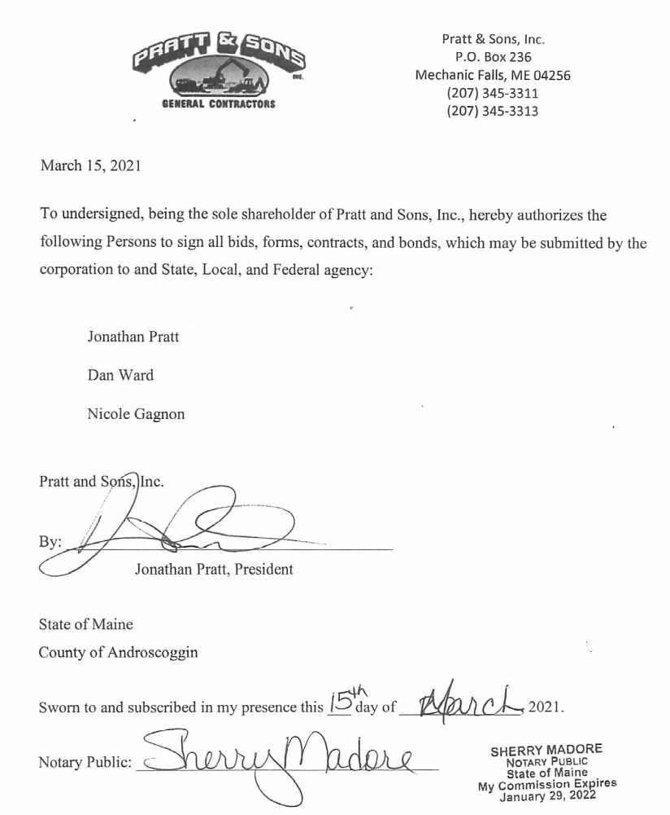

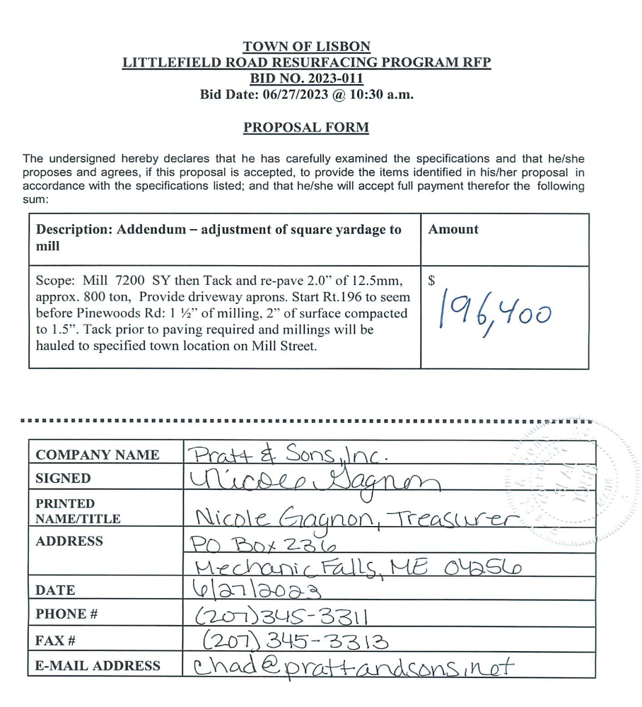
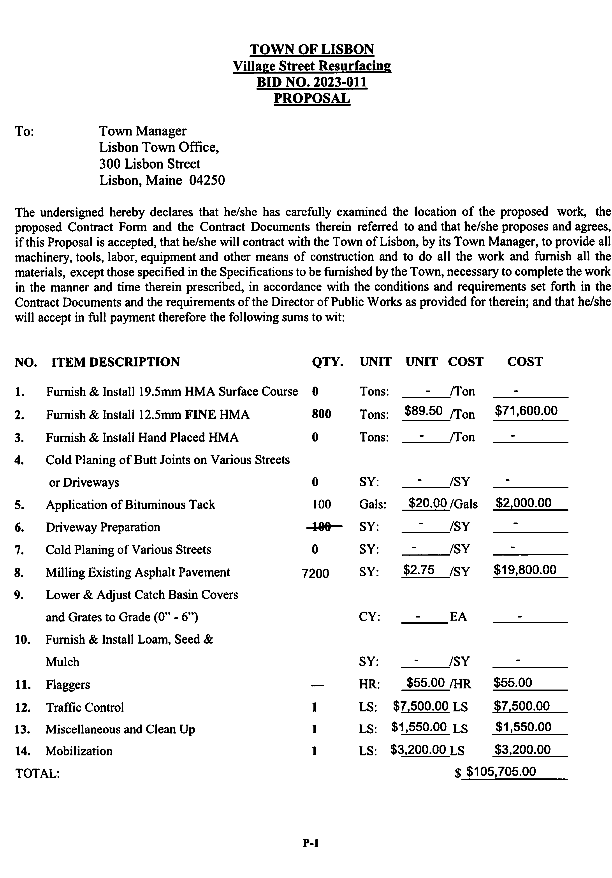

Mr. Michalowski said there is money left over in the bond from Ferry Road. He said he will follow up with the Public Works Director and Finance Director and come back to Council in August.
VOTE (2023-141) Councilor Fellows, seconded by Councilor Robishaw, moved to award to the contract for Village Street road resurfacing to St. Laurent & Sons as the low bidder in the amount of $105,705.00.
Order passed – Vote 7-0.
OTHER business
Council Remote Meeting Policy Discussion
Item taken up out of order at beginning of meeting.
Discussion about addition of a stop sign on River Road
Mr. Michalowski said this was in response to complaints about speeding at Hudon Road. He advised that to add a stop sign we will need to make an ordinance change.
Councilor Fellows explained that the man who owns a farm down the road has stated there is too much speeding on the road and recommends two stop signs for the three-way intersection.
Chief McGee said it is a dead end road and many years ago, there was a sign there. He said the Police Department has looked at it; we could put a stop sign back where it was. He added that there are only a handful of houses on the road, we could go door-to-door and explain to people who drive on the road that the speed is 35 MPH. He said that Public Works could clear the weeds blocking the speed limit signs. He said the Police Department does not know who is speeding, or what vehicle it is. He also explained that the road is on the ordinance list of roads with stop signs, so we would need to change the ordinance in order to add a stop sign. He said the old stop sign was on the old dirt road, which is now paved.
Councilor Moore said it sounds like there is one person causing the issue.
Chief McGee said one option would be to send a letter to those houses on the road. He said we can put the speed trailer there to document speeding, as well.
Councilor Fellows requested that Chief McGee follow up with the complainant.
Councilor Larochelle suggested the possibility of adding a line to the ordinance for stop signs to make it at the discretion of Public Safety.
Mr. Michalowski said he can have staff make recommendations for changes to the ordinance.
COUNCIL COMMITTEE REPORTS
- School: Councilor Cain said there has not been a recent meeting, only a special one to approve staffing.
- Planning Board: Councilor Fellows said the next meeting is July 27, they will hear 5 conditional applications. He said there was more discussion at the July 7 meeting regarding Rural Open Space I and II zones, with the idea of allowing more residential in those areas.
- Lisbon Development Committee: Ross Cunningham said the LDC is working on the abandoned properties issue, continues to develop ideas for the Worumbo site, and talked about the old landfill as well. He said they meet again in August.
- Conservation Commission: Councilor Moore said he does not know when the next meeting will be.
- Recreation Committee: Councilor Larochelle said there was no meeting due to the Moxie Festival.
- County Budget Committee: Councilor Moore said there was nothing to report.
- Library Governing Board: Councilor Keller said the summer reading program has 165 kids and 56 adults, an increase over past years. She said that 1/3 of the readers are new. She also said there was a successful book sale with the Methodist Church and the New Friends of the Library group.
- Water Commission: Councilor Fellows said the corrosion control work continues, and the Water Department is working on backflow preventer incentives and making the abatement process more structured.
- Finance Committee: Councilor Robishaw said there was no meeting.
TOWN MANAGER’S REPORT
- The fuel tank at Public Works is complete.
- 1-2 volunteers from the Town Council are needed to start the consolidation talks with Lisbon Emergency Services. Councilors Larochelle and Robishaw volunteered; the first meeting is August 3rd.
- Library Director interviews begin next week.
- Phone systems: In March we were told the phones were being discontinued, we extended to September and the Assistant Manager is working to find new phones and service. Mr. Michalowski added that the Police Department will get better service and we will bring down costs to see some savings.
- We are looking to outsource Payroll.
- Fuel pricing: we use Maine Power Options to lock in pricing for fuel. Mr. Michalowski asked for Council to waive the bid process.
VOTE (2023-141A) Councilor Larochelle, seconded by Councilor Fellows, moved to waive the bid process and allow the Town Manager to execute a contract for fuel for the lowest pricing option.
Order passed – Vote 7-0.
- CMP supply rates are going up by $10,000 to $12,000 this year.
Announce Nomination Papers for the November 7, 2023 Annual Municipal Election – Available on July 31st
The Town Clerk announced that nomination papers will be available for the November Election on Monday, July 31st. The openings include one 3-year and one 2-year term for the School Committee and one 3-year term for the Town Council.
APPOINTMENTS
Appointments to the Ethics panel and the finance committee
VOTE (2023-141B) Councilor Fellows, seconded by Councilor Larochelle, moved to appoint Sam Prindle to the Ethics Panel and the Finance Committee.
Councilor Larochelle requested that we ask the Chair of the Ethics Panel for a recommendation for appointments to the Panel. Chairman Moore requested that the Clerk ask the candidates to attend an Executive Session at the next meeting in August so that Councilors can speak with them and consider the applications.
Councilor Fellows withdrew his motion for the Ethics Panel appointment. Councilor Larochelle withdrew his second.
councilor COMMUNICATIONS
Councilor Fellows said, in follow-up to the discussion about the remote policy, he would like to clarify what we are doing—A, nothing; B, the Attorney’s recommendation; or C, Councilor Fellows recommendation. The Town Clerk offered to work with staff on the remote policy.
AUDIENCE PARTICIPATION & response FOR NEW ITEMS
Mr. Cunningham said that on June 1st a new website for the Town was launched: DiscoverLisbonMe.org. He also said that the planning process for Lisbon’s 225th birthday celebration for 2024 has begun and a committee of staff and volunteers will meet soon to get that started.
adjoURNment
VOTE (2023-142) Councilor Fellows, seconded by Councilor Keller, moved to adjourn at 10:08 PM.
Order passed – Vote 7-0.

Lisa M. Ward, Council Secretary
Town Clerk
Date Approved: August 15, 2023

