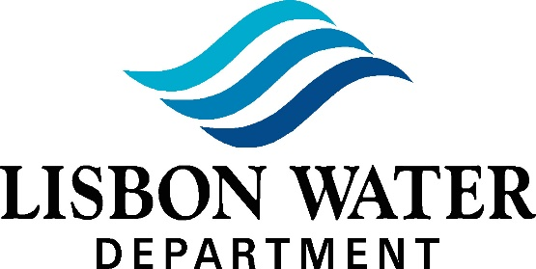

639 Lisbon Road

Lisbon Falls, Maine 04252

Tel. (207) 353-3020

Arthur McLean, Chairman, Roger Bickford & Marie Hale Commissioners

Charles Harrison, General Manager

Water Commission Minutes for February 8, 2022

Members Present: Arthur McLean, Marie Hale, Roger Bickford

Staff Present: Chuck Harrison, Shellie Reynolds

Audience: Don Fellows - Liaison for Town of Lisbon Council

- CALL MEETING TO ORDER

Meeting called to order by Mr. McLean at 5:30pm

Roll Call
- AUDIENCE PARTICIPATION

None
- WARRANTS

Warrant #3022 (Jan 21, 2022)

Warrant #4022 (Jan 26, 2022)

Warrant #5022 (Feb 2, 2022)

Warrant #6022 (Feb 9, 2022)
- OLD BUSINESS
  - Minutes
    - 1/11/2022-Meeting Minutes
      - Ms. Hale made motion to accept, Mr. Bickford 2nd, followed by a 3/0 vote in favor.

Corrosion Control
    - Still working on tanks; still no communication from vendor as to where tanks are in process of manufacturing.

Finish Pump Repair/Replacement
    - In process still

Route 125 Project
    - Nothing official from State but we know contract was signed by Magee so we ordered material w/EJP.
    - Lisbon Water is not going after bond for spring issue due to the short notice and the amount of prep time it takes to prepare a bond. We do have other options if needed before fall issue.

Unresolved Issues (tabled)
    - T-Mobile Proposal – New Generator
    - Route 125 Project
    - Memorial for Bill Bauer – Plaque wording and placement
    - 9 Merrill Ave Development
    - Legislative Bill for PFO’s PFA’s
      - Lisbon Water is testing every 3 months in order to get a baseline.
      - We have not been close to the minimum level.
      - Mr. Harrison hoping we get the state requirements for 2022 soon.
    - Master Plan
    - Chlorination at Stations

Any Other Old Business
    - T-Mobile Proposal – New Generator; in attorney’s hands.
    - No spring issue bond for 125 project
- NEW BUSINESS

General Manager’s Report
    - Main Break – 1/25/2022 – Osborn Street
      - 6” main line break
    - Broken Line – 1/13/2022 – 65 Main Street: issue on customers side, service still off.
    - Increases
      - Sam Langdon passed the Distribution portion of his license so he is a fully licensed Level I Operator.

Business Manager’s Report
    - Audit – 3/22/2022 through 3/24/2022
    - Audit Prep – 2/18/2022 with Nick Henry (Horton, McFarland and Vesey)

Commissioner Communication/Requests
    - Ms. Hale –
      - Will review the books through the end of the year and then they will talk about Mr. McLean taking that over.
      - Asked if Mr. McLean planned on running for commissioner this year.
        - Mr. McLean answered that he does plan to.
    - Mr. Bickford – None
    - Mr. McLean
      - Asked if the guys liked the conference
        - Mr. Harrison said they did well & came away with a lot of information.

Customer Communication
    - Complaint Log
      - 2/3/2022 – 17 Crest Ave. – Water smelled of chlorine
        - Mr. Harrison went to home and tested water which tested ok at .53 and .54.
        - Mixers in tank will help maintain levels.
      - 2/3/2022 – 12 Park St. – Dirty water has clogged fixtures
      - Customer blamed line break at 10 Park St. but Mr. Harrison stated this could not have been the issue because it was not the main but a personal service line.
      - 2/8/2022 – 11 Union St. – Stagnant water
        - There is a broken valve on Rte. 196 so that may be causing the issue. Operators flushed hydrant; this water was very dirty so we will flush more often.
    - Customer Comments
      - Customers upset about lobby being locked and having to mask.

Any Other New Business
    - New truck has been ordered and should be delivered soon.
    - Bathroom/breakroom changes; pulling breakroom out of operations office.

Set next meeting date
    - Tuesday, March 8, 2022 at 5:30pm at Lisbon Water Department.
- ADJOURNMENT
  - Ms. Hale made motion to adjourn, Mr. Bickford 2nd, followed by a 3/0 vote in favor. Adjourned at 6:04pm.

